# **IST769 Homework Submission**

Name: **Sathish Kumar Rajendiran**   
SUID: **666555028**  
Email: srajendi@syr.edu  
Date Due: **08/10/2021**

Date Due: **HDFS, MapReduce and YARN**

Homework #:**5**

**Exercise(s):**

1. Upload all the documents in datasets/text into a folder called text in HDFS. What HDFS command must you run to verify the files are there after they are uploaded? Your answer should consist of the command you typed to complete the task.

**Solution:**

--list available folders

**hdfs dfs -ls**

--create a folder for “text”

**hdfs dfs -mkdir text**

--upload *.txt files into “text” folder from datasets/text folder

**hdfs dfs -put datasets/text/*.txt text/**

--list available files

**hdfs dfs -ls text**

**Evidence:**

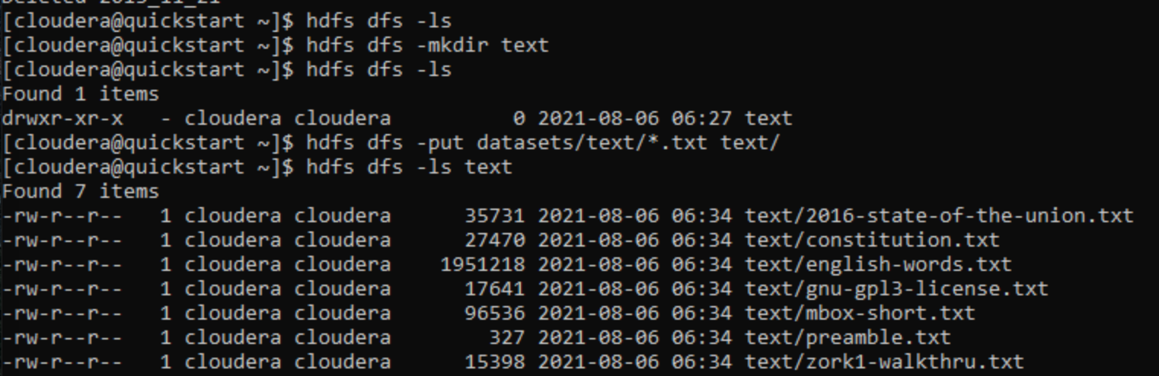

1. In this part you will upload the clickstream dataset to HDFS. Specifically, create a clickstream folder in HDFS, then create a logs and iplookup folder inside the clickstream folder. Upload all the *.log files from the datasets/clickstream local folder into clickstream/logs in HDFS. Upload the ip_lookup.csv file from the same folder into clickstream/iplookup on HDFS. Verify the files are there. Your answer should consist of the commands you typed to complete the task.

**Solution:**

--create a folder for “clickstream”

**hdfs dfs -mkdir clickstream**

--create sub folders for “clickstream” as “logs” and “iplookup”

**hdfs dfs -mkdir clickstream/logs**

**hdfs dfs -mkdir clickstream/iplookup**

--upload *.log files into “logs” folder from datasets/clickstream folder

**hdfs dfs -put datasets/clickstream/*.log clickstream /logs/**

--upload *.csv files into “iplookup” folder from datasets/clickstream folder

**hdfs dfs -put datasets/clickstream/*.csv clickstream /iplookup/**

--list available files

**hdfs dfs -ls clickstream/logs**

**hdfs dfs -ls clickstream/iplookup**

**Evidence:**

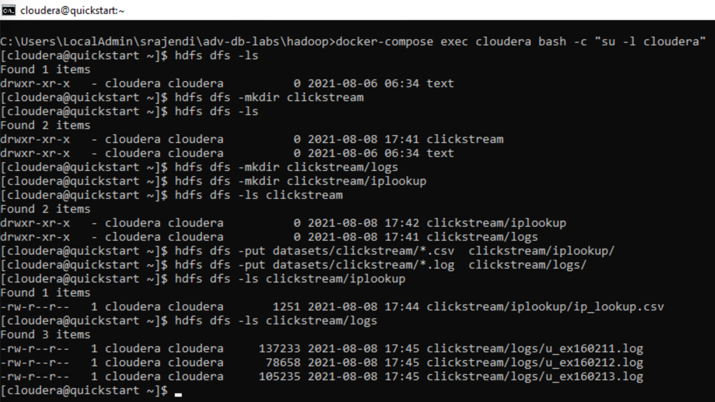

1. Use the MapReduce examples:  
   export MREX=/usr/lib/hadoop-mapreduce/hadoop-mapreduce-examples.jar   
   to perform a wordcount on the 2016 State of the Union address, saving the output to the HDFS folder sotu2016. Write down the commands to complete the task. How many times does the word are appear in the 2016 State of the Union address? Describe a process which could be done to make the wordcount more useful?

**Solution:**

--view the contents of the 2016 state of the union address

**hdfs dfs -cat /user/cloudera/text/2016-state-of-the-union.txt**

--define MapReduce jar

**export MREX=/usr/lib/Hadoop-mapreduce/Hadoop-mapreduce-examples.jar**

--perform wordcount on 2016 state of the union address

**yarn jar $MREX wordcount /user/cloudera/text/2016-state-of-the-union.txt /user/cloudera/sotu2016**

--view the output file

**hdfs dfs -ls sotu2016/**

**hdfs dfs -cat sotu2016/part-r-00000**

--copy file to local

**hdfs dfs -get sotu2016/part-r-00000 sotu2016.csv**

--Later, we can perform visualization on this using R or Python for frequency plot, top 10 occurrences, after removing stop words and other text processing, we can plot word cloud or perform sentiment analysis.

Evidence:

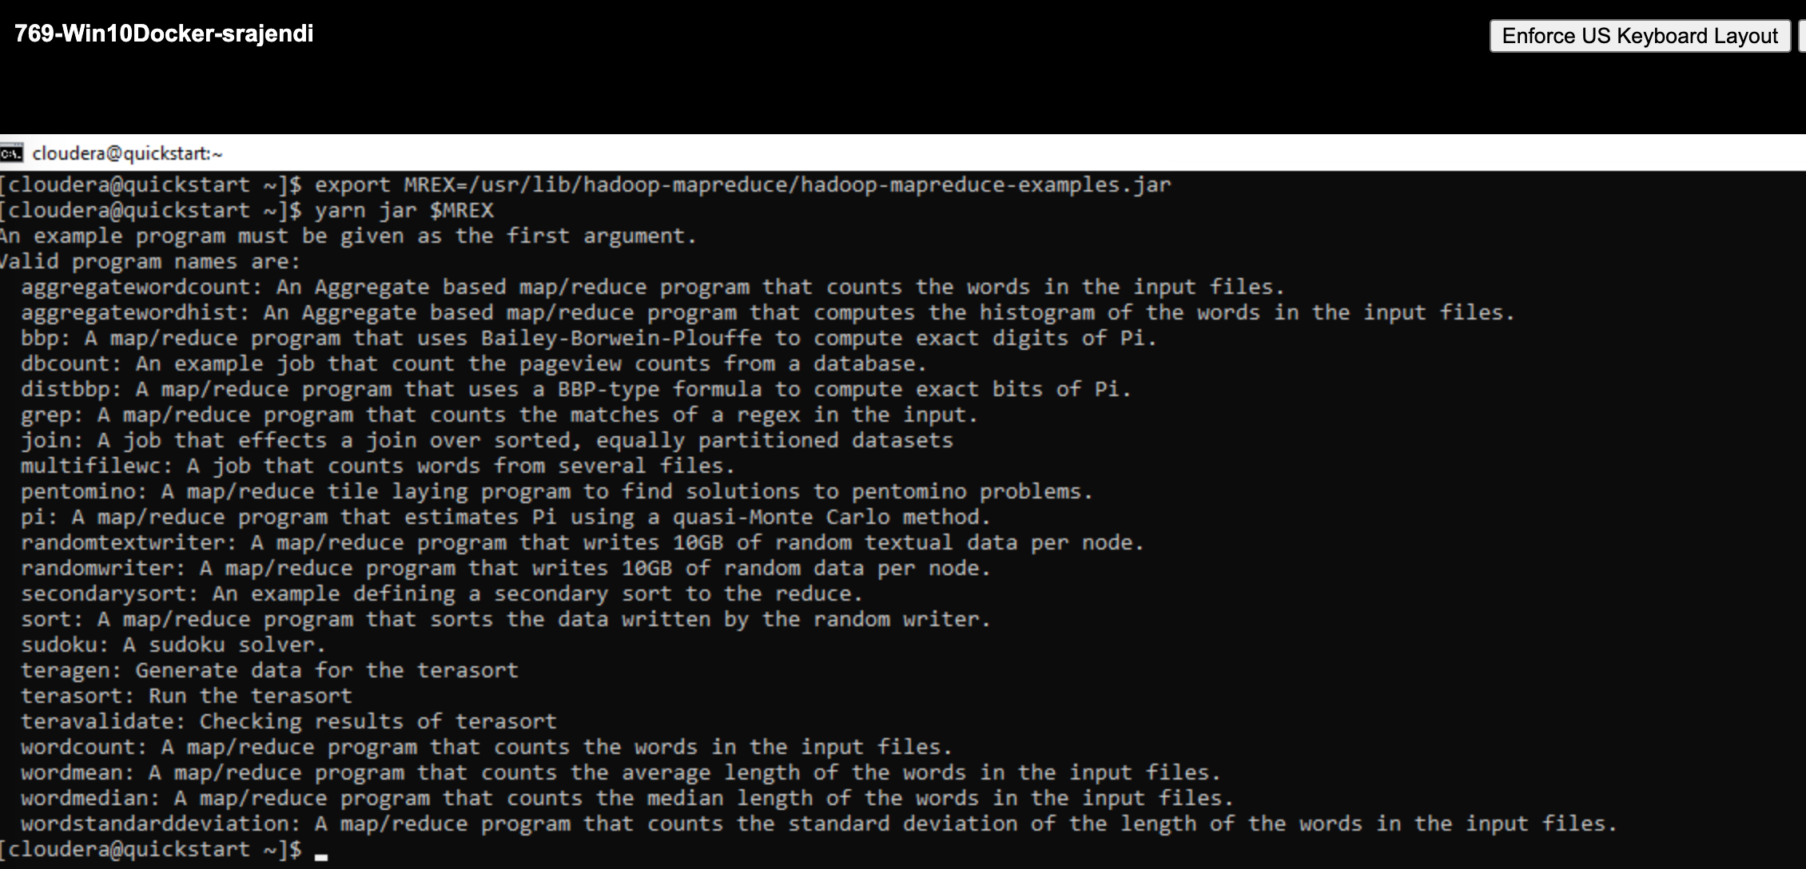

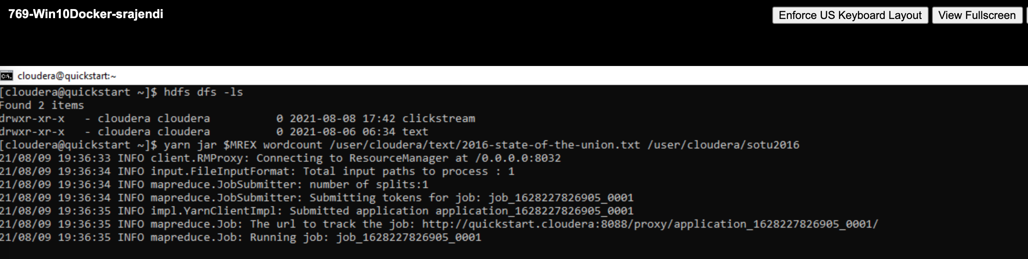

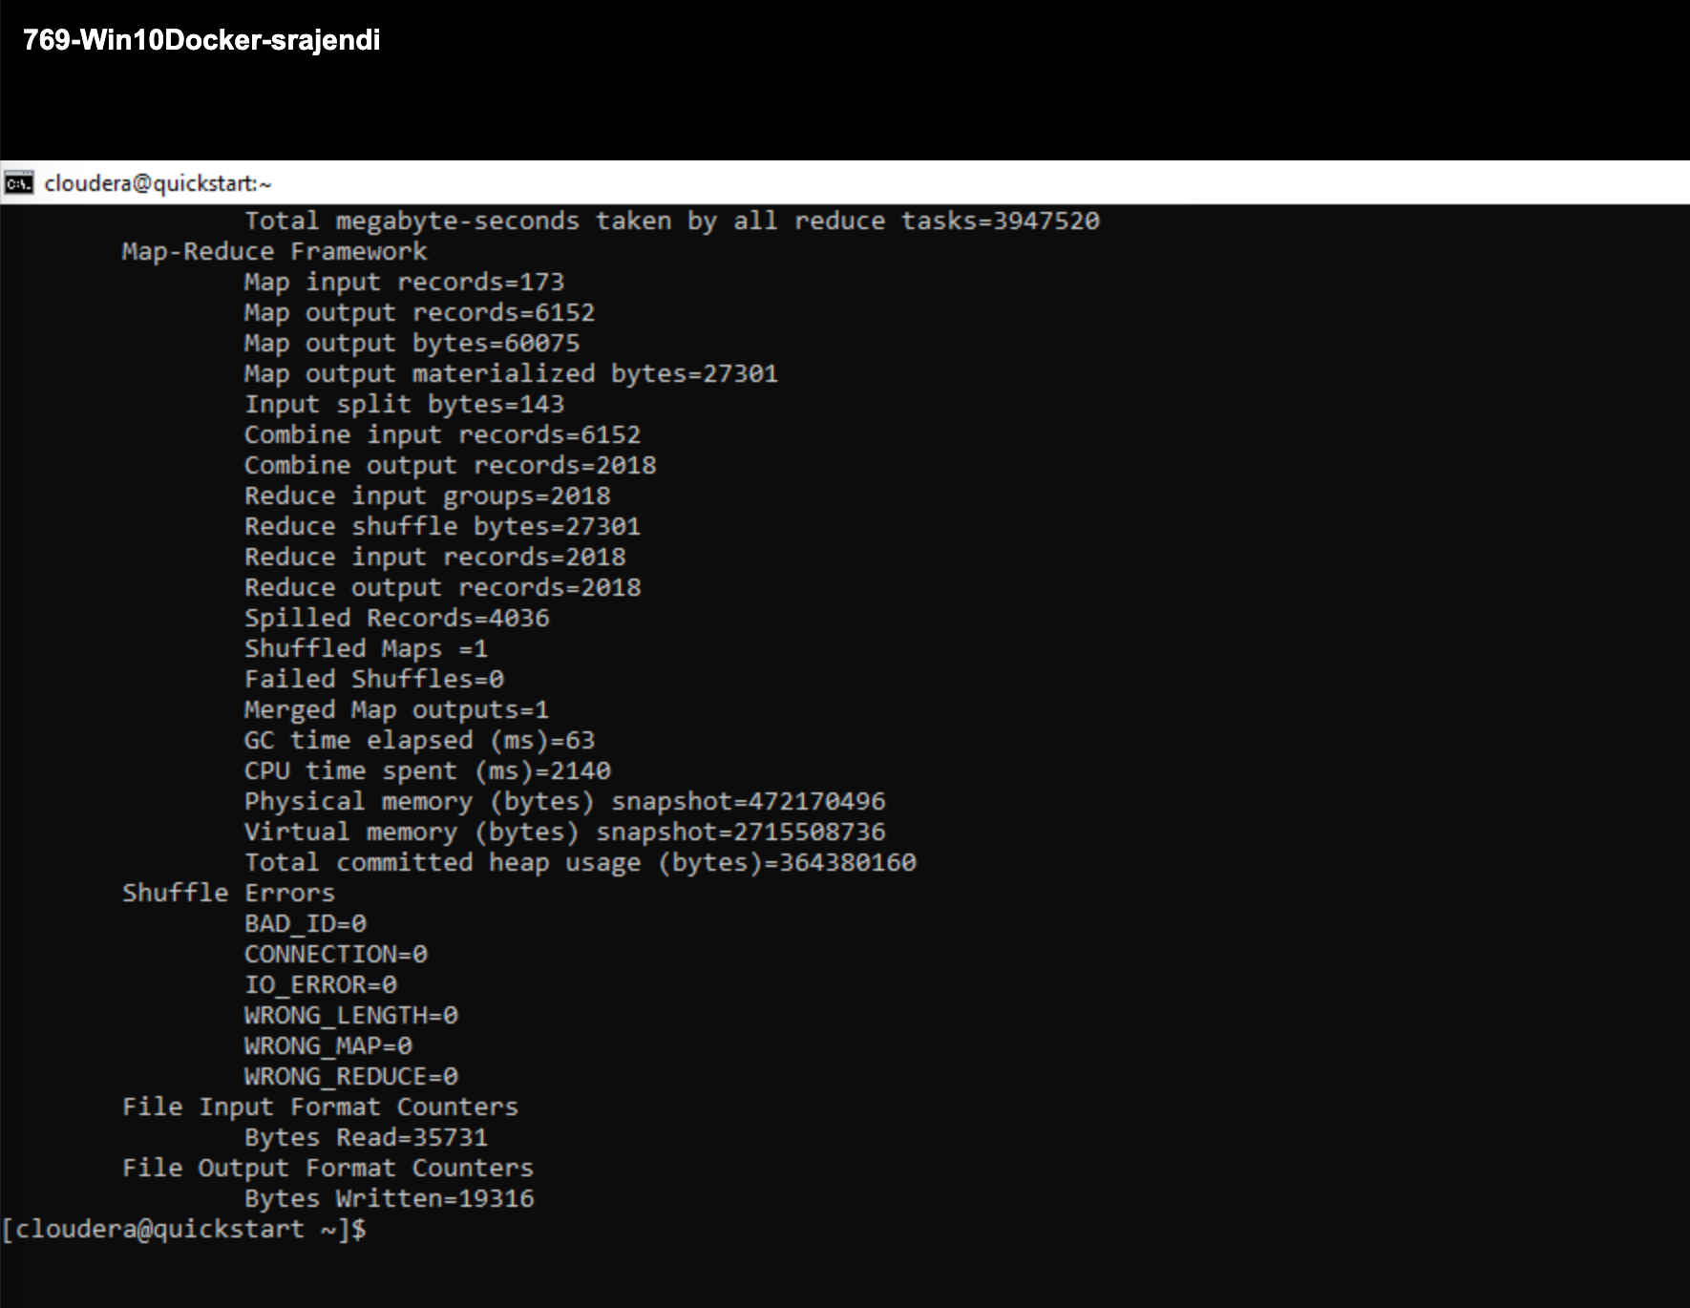

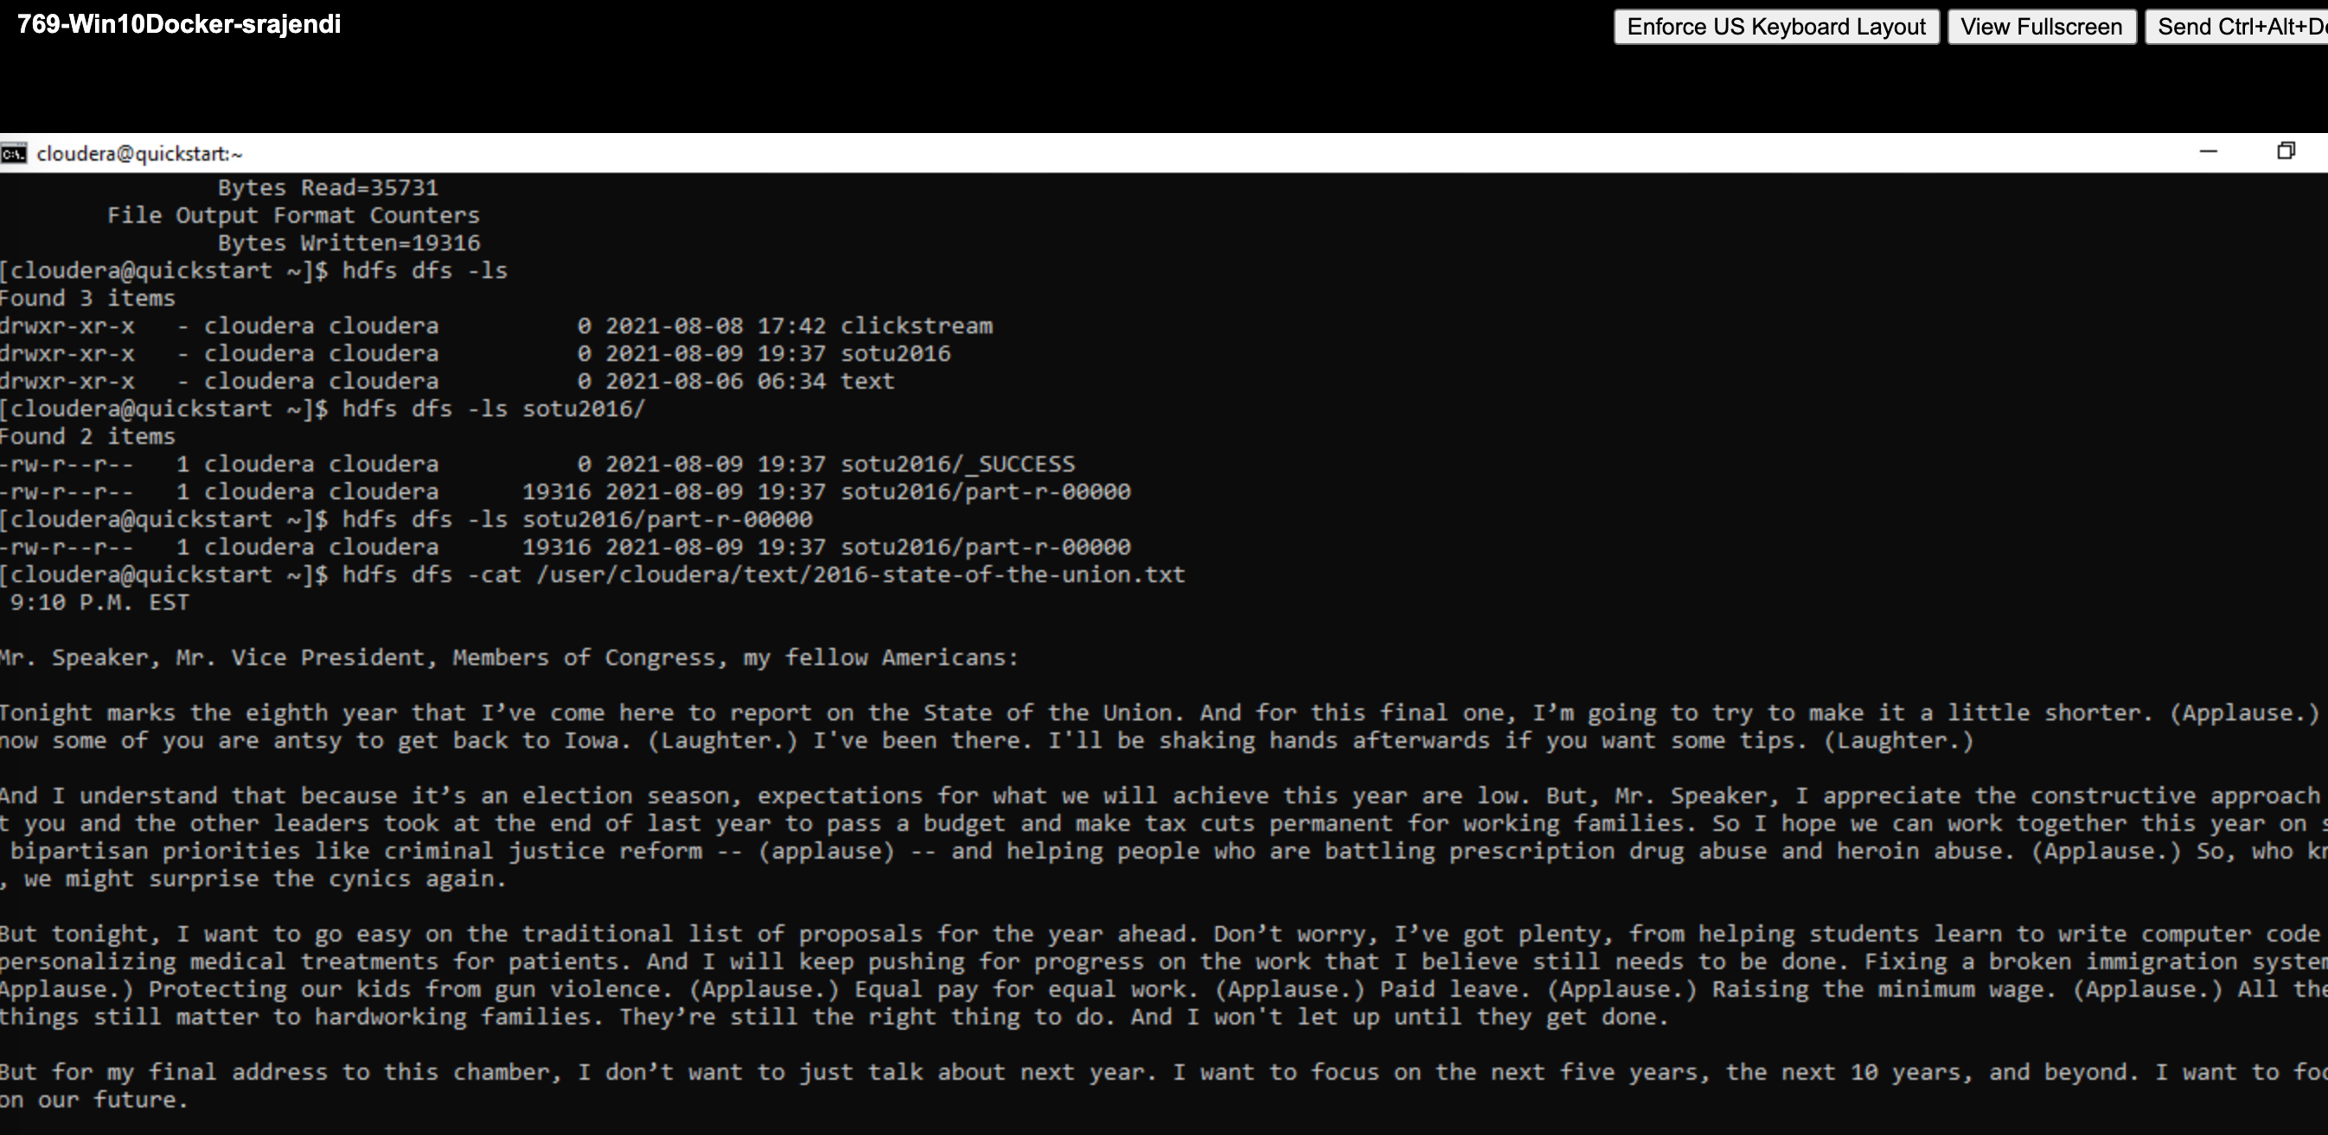

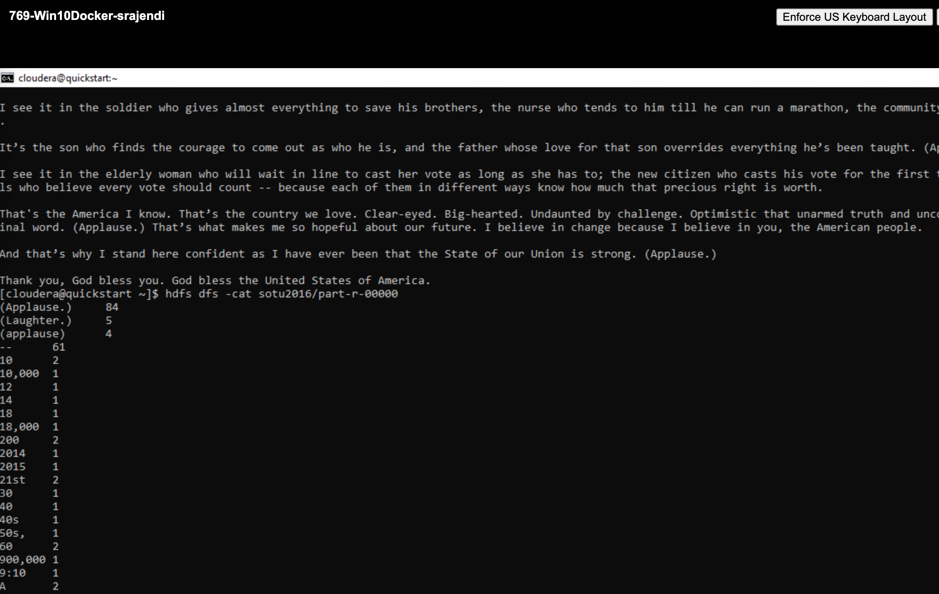

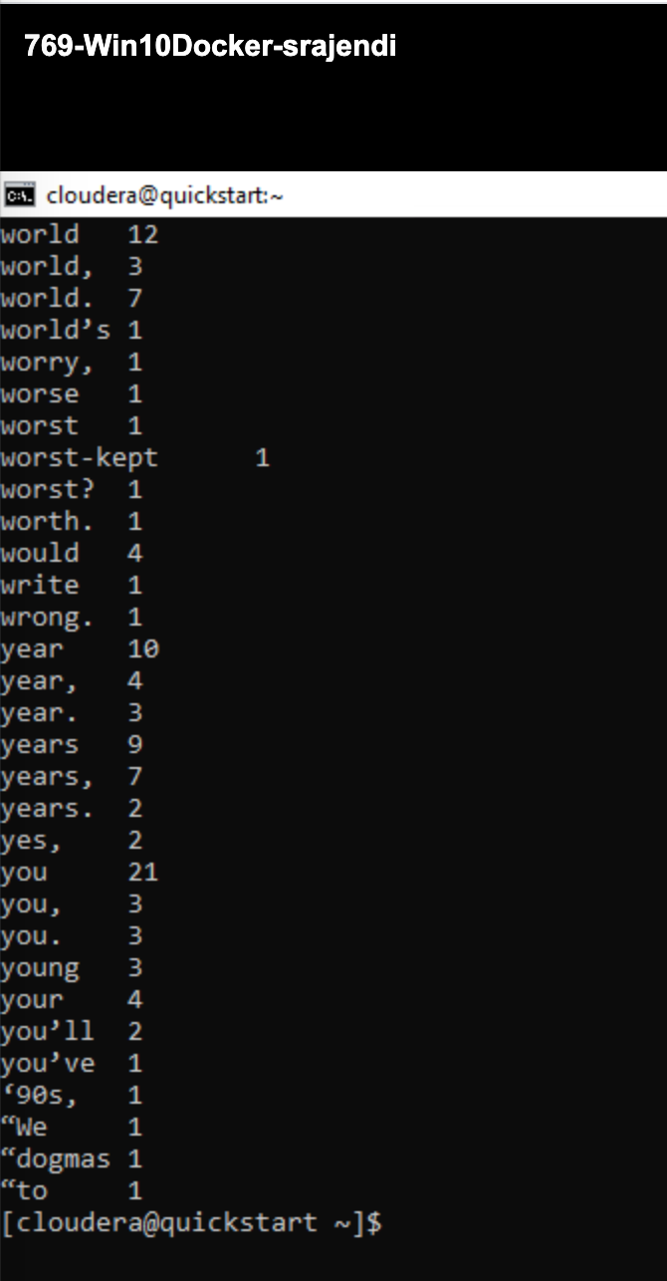

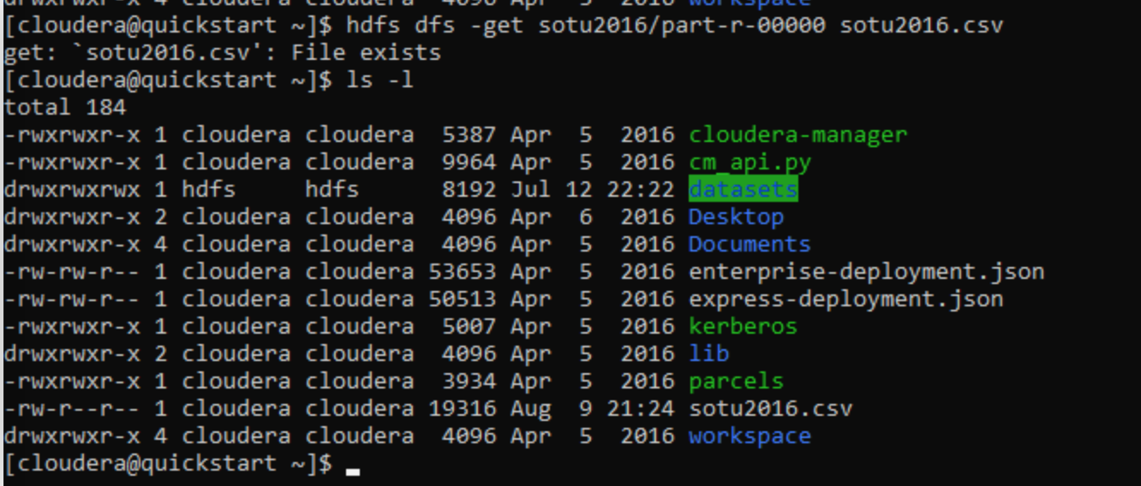

1. Type the following command to import the fudgemart_v3 database into the local mysql instance on the Hadoop client:  
   mysql -u root -p < ~/datasets/fudgemart/mysql.sql   
   The password is cloudera. Write down the commands you used to complete these tasks:  
   Use the sqoop utility to verify there are tables in the database by listing them from the fudgemart_v3 database. Next write a sqoop command to import Fudgemart products in the ‘Clothing’ department into a HDFS folder /user/cloudera/fudgemart-clothing

**Solution:**

--import fudgemart_v3 database into local mysql instance

**mysql -u root -p < ~/datasets/fudgemart/mysql.sql**

--list databases using sqoop

**sqoop list-databases --connect jdbc:mysql://cloudera --username=root --password=cloudera**

--list tables using sqoop

**sqoop list-tables --connect jdbc:mysql://cloudera/fudgemart_v3 --username=root --password=cloudera**

--import into HDFS using sqoop

**sqoop import --connect jdbc:mysql://cloudera/fudgemart_v3 --username=root --password=cloudera --target-dir /user/cloudera/fudgemart-clothing –query “select *from fudgemart_products where product_department=’clothing’ and \$CONDITIONS” --as-textfile –split-by-product_name**

--verify the HDFS

**hdfs dfs -ls fudgemart-clothing**

--view the data

**hdfs dfs -cat fudgemart-clothing/part-m-00004**

**Evidence:**

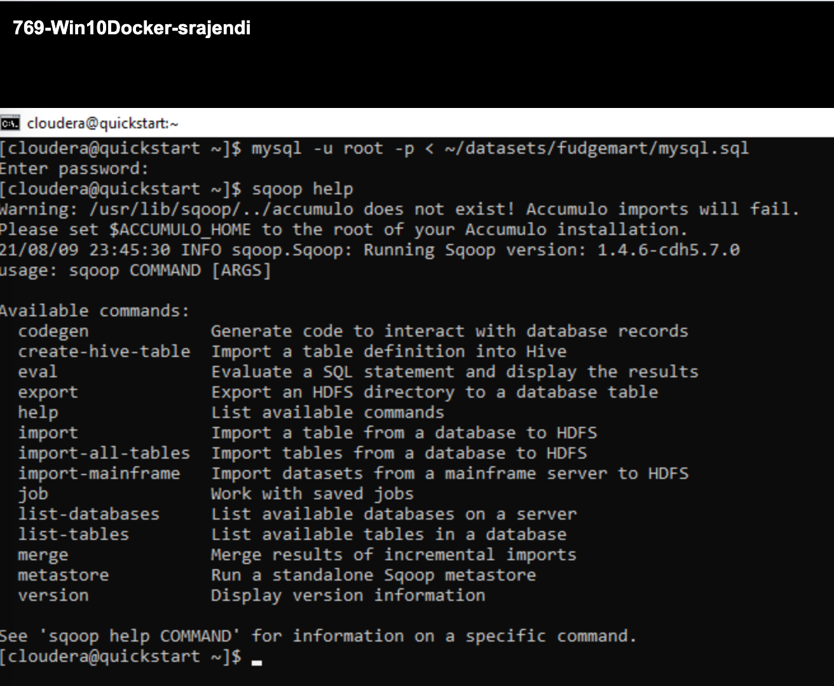

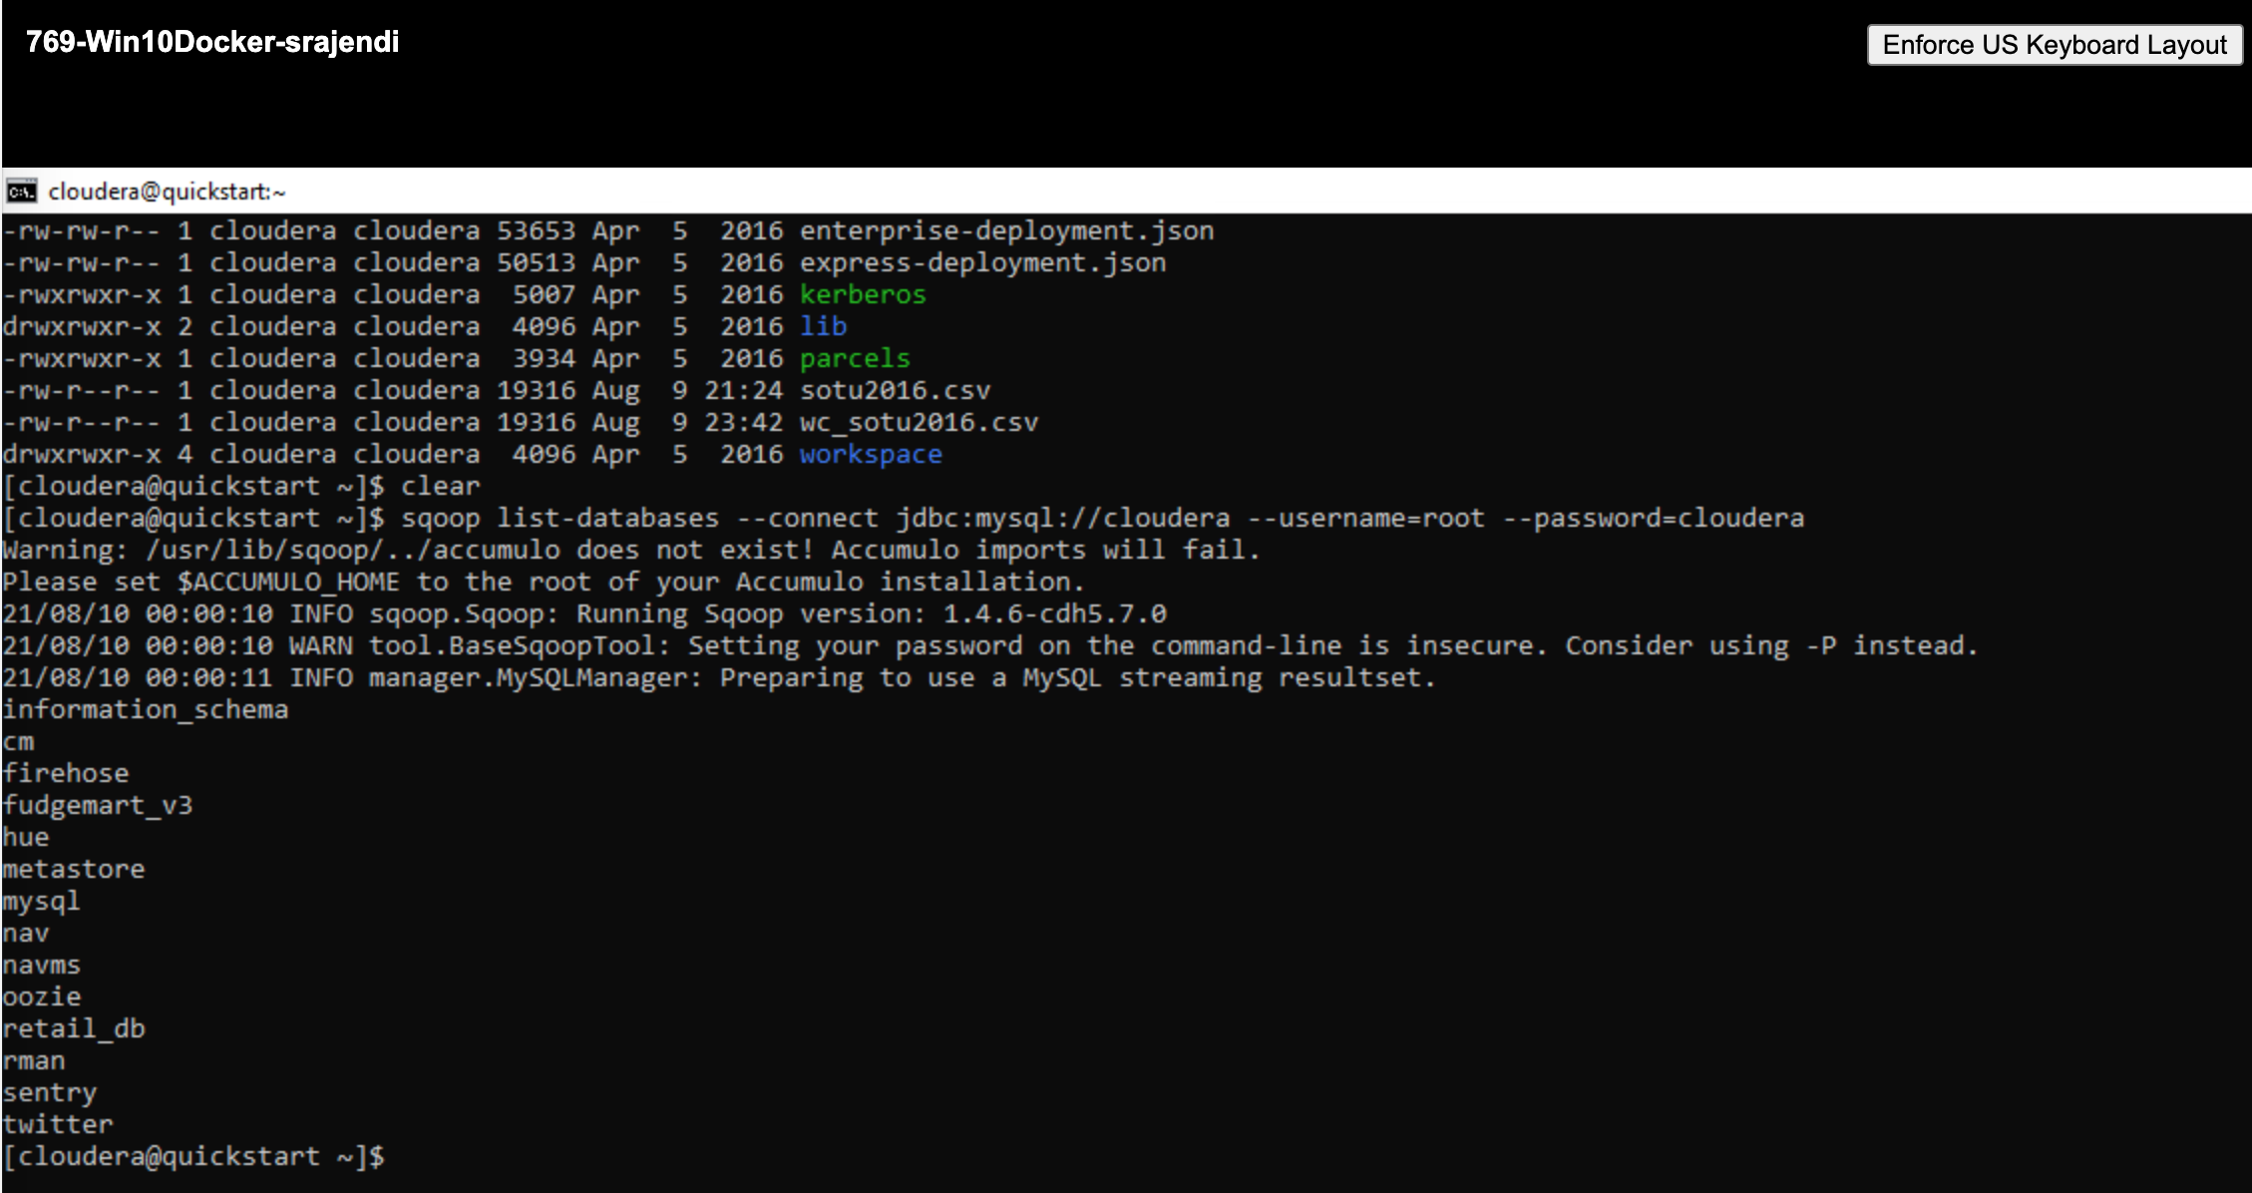

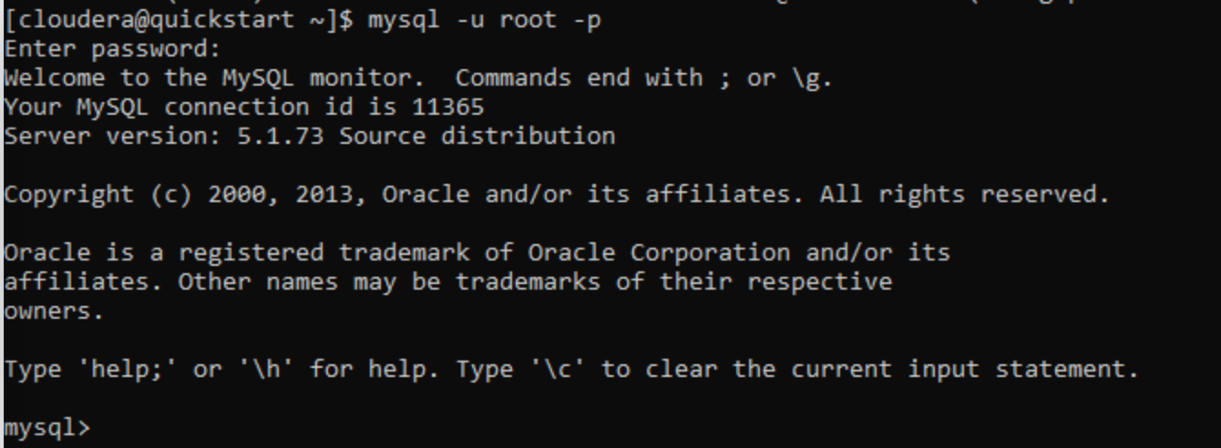

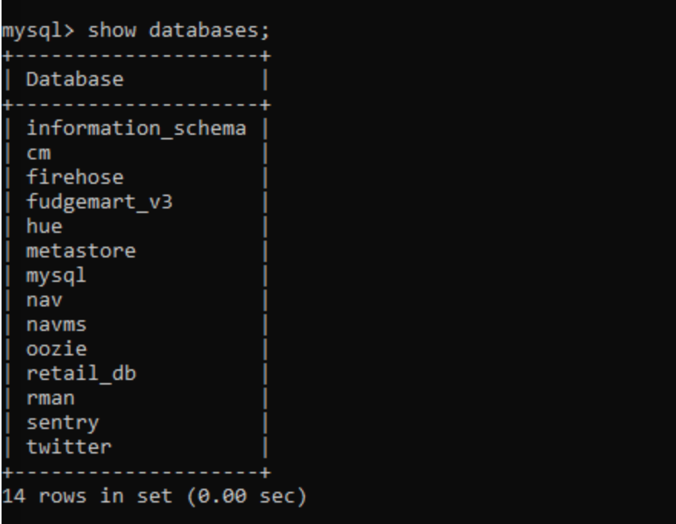

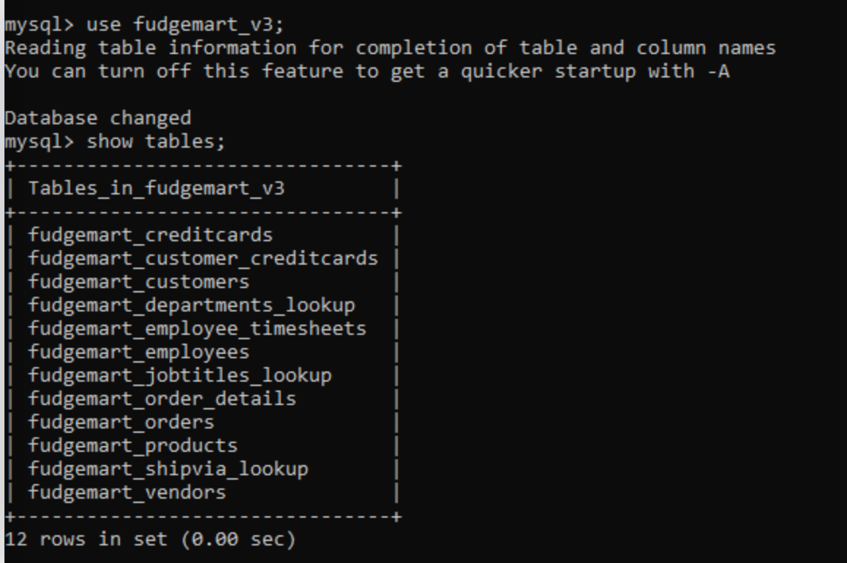

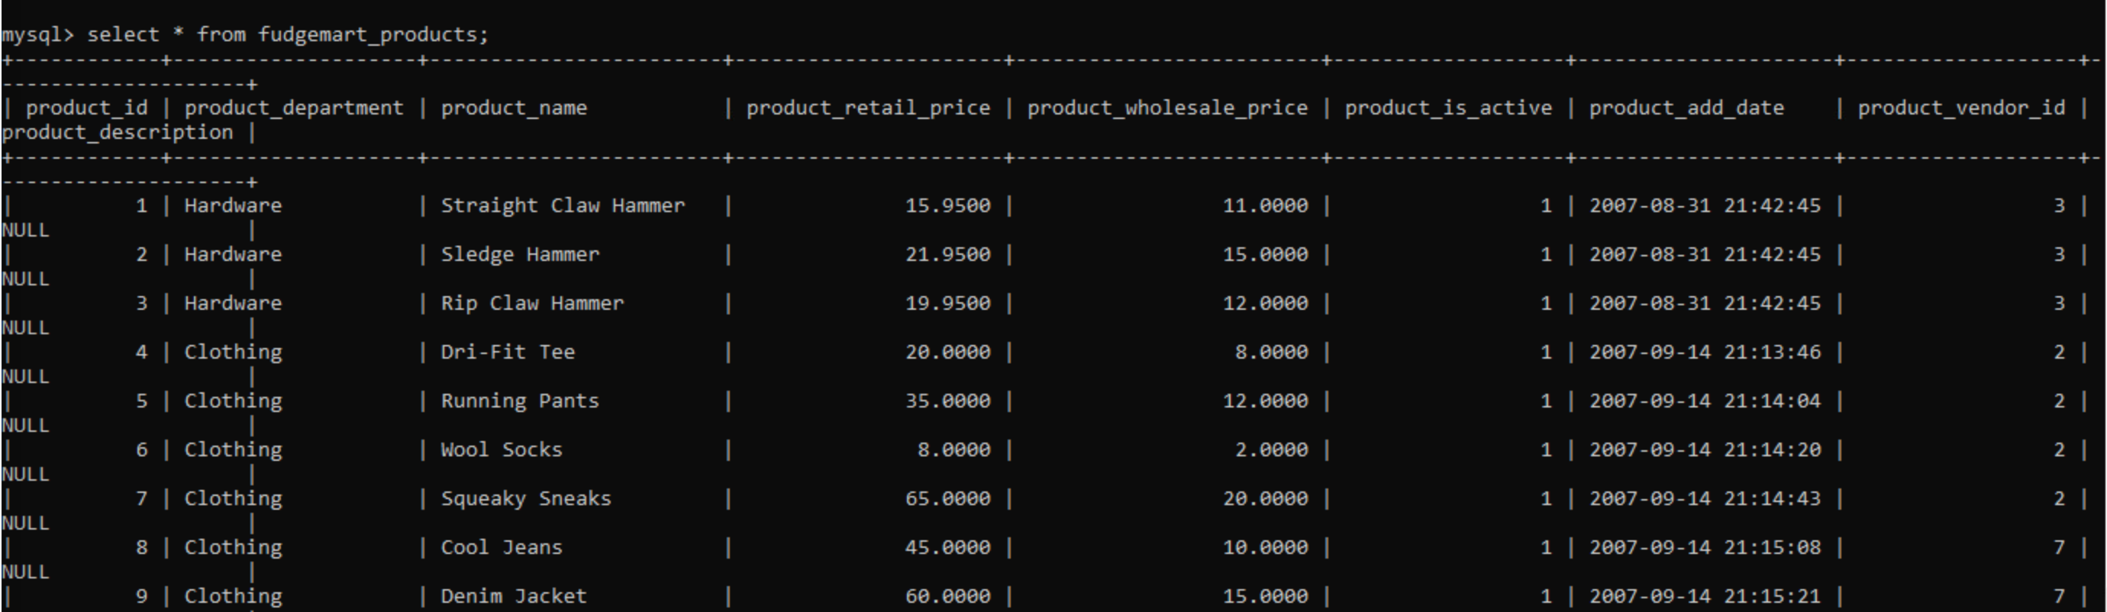

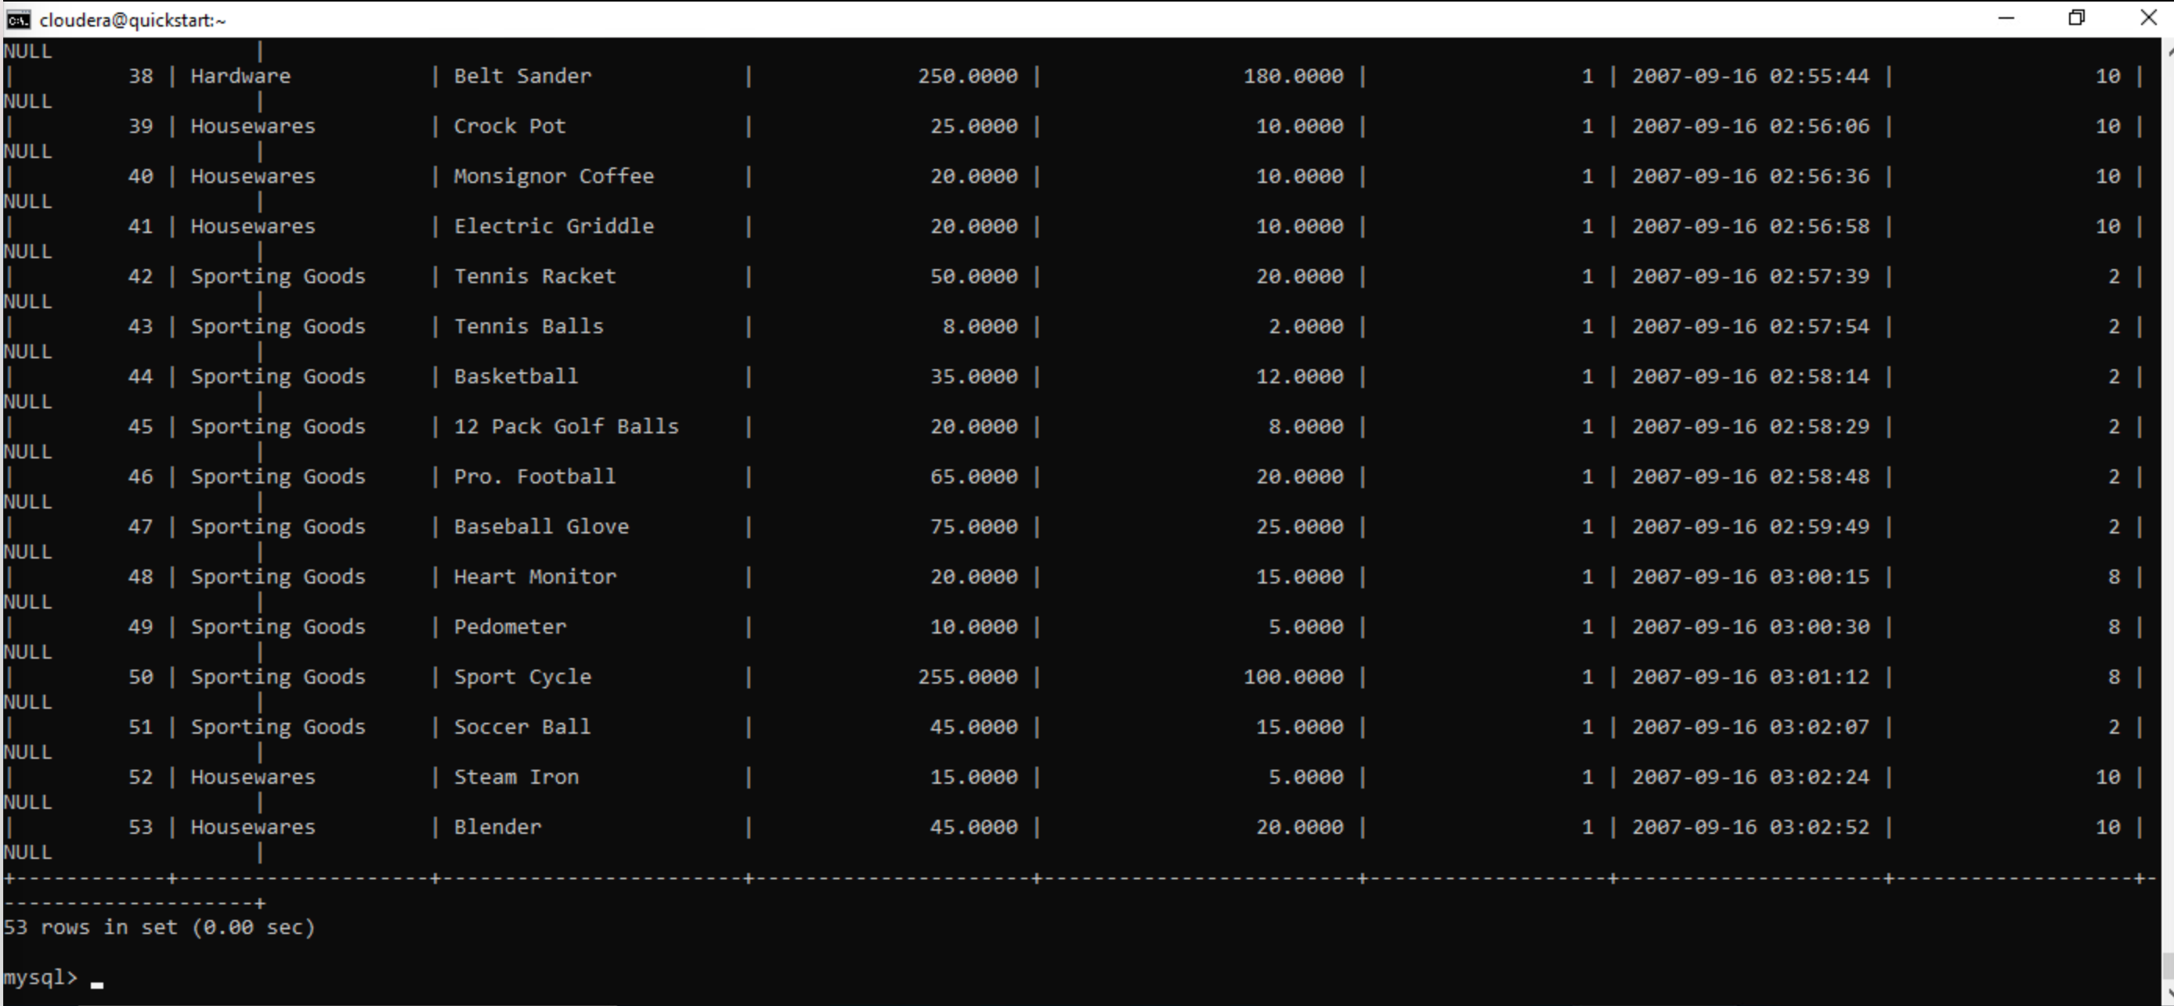

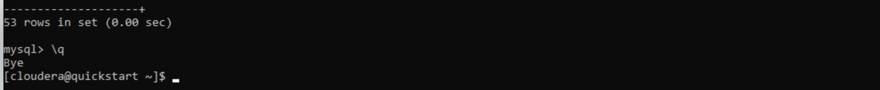

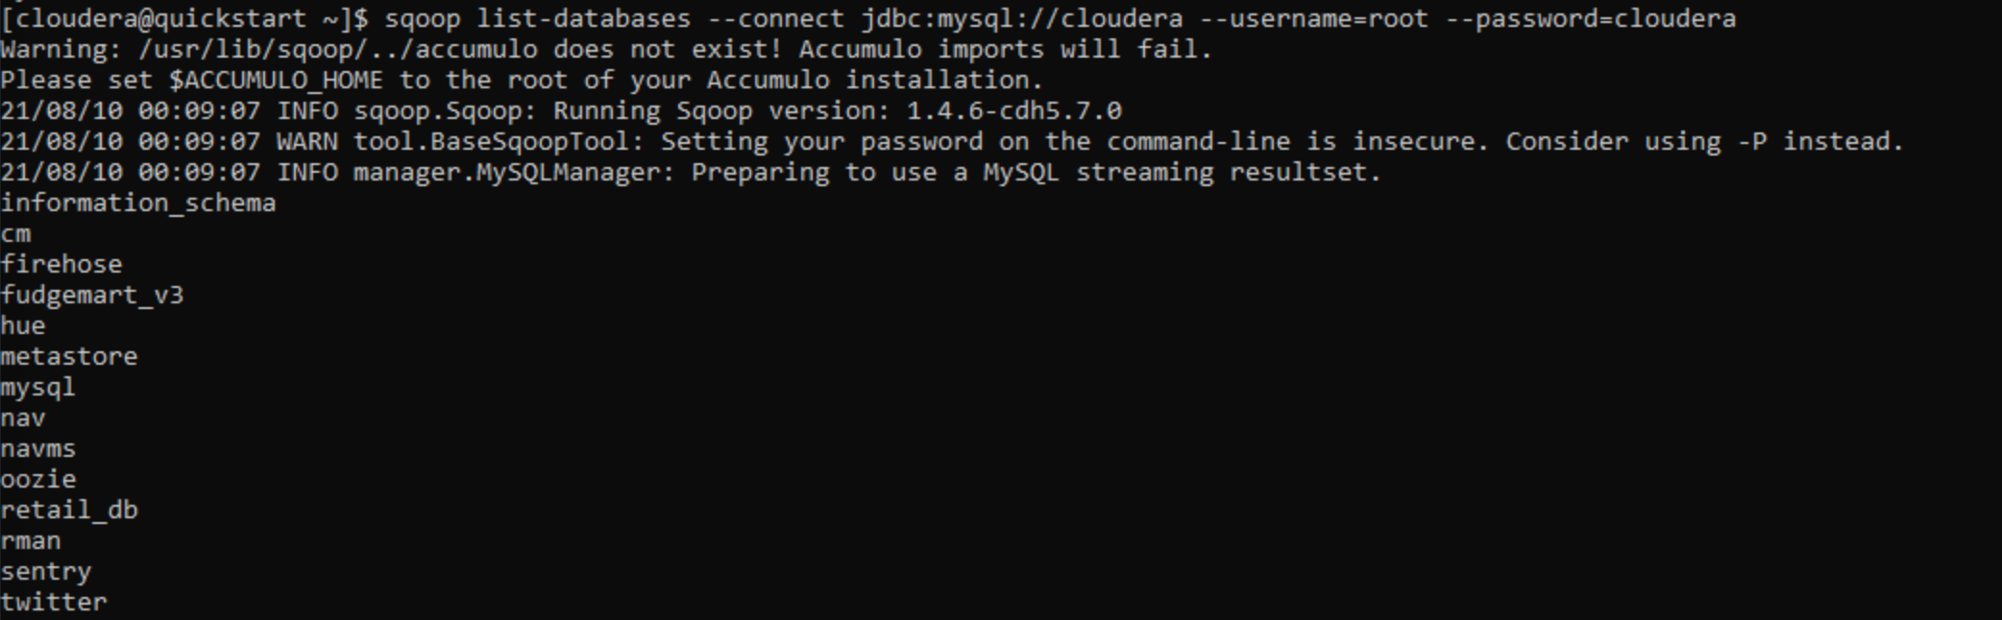

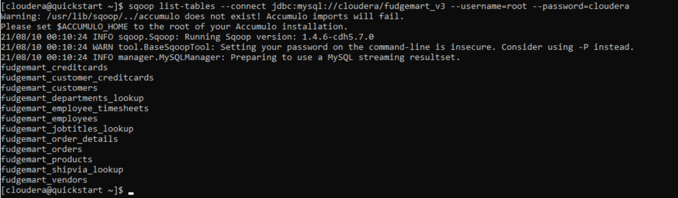

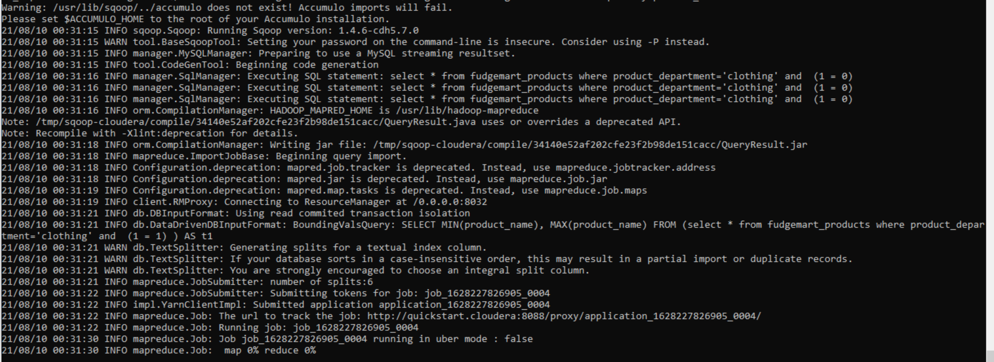

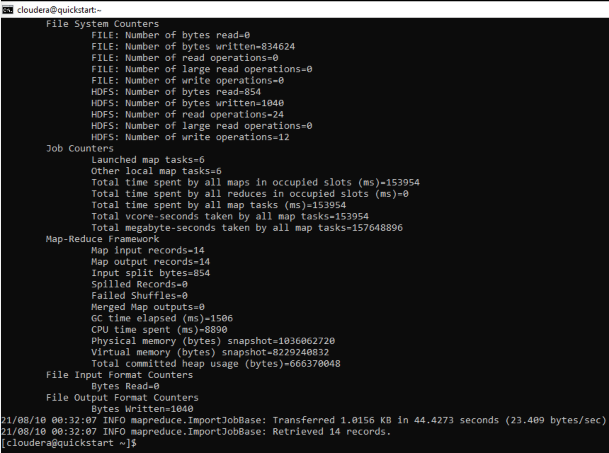

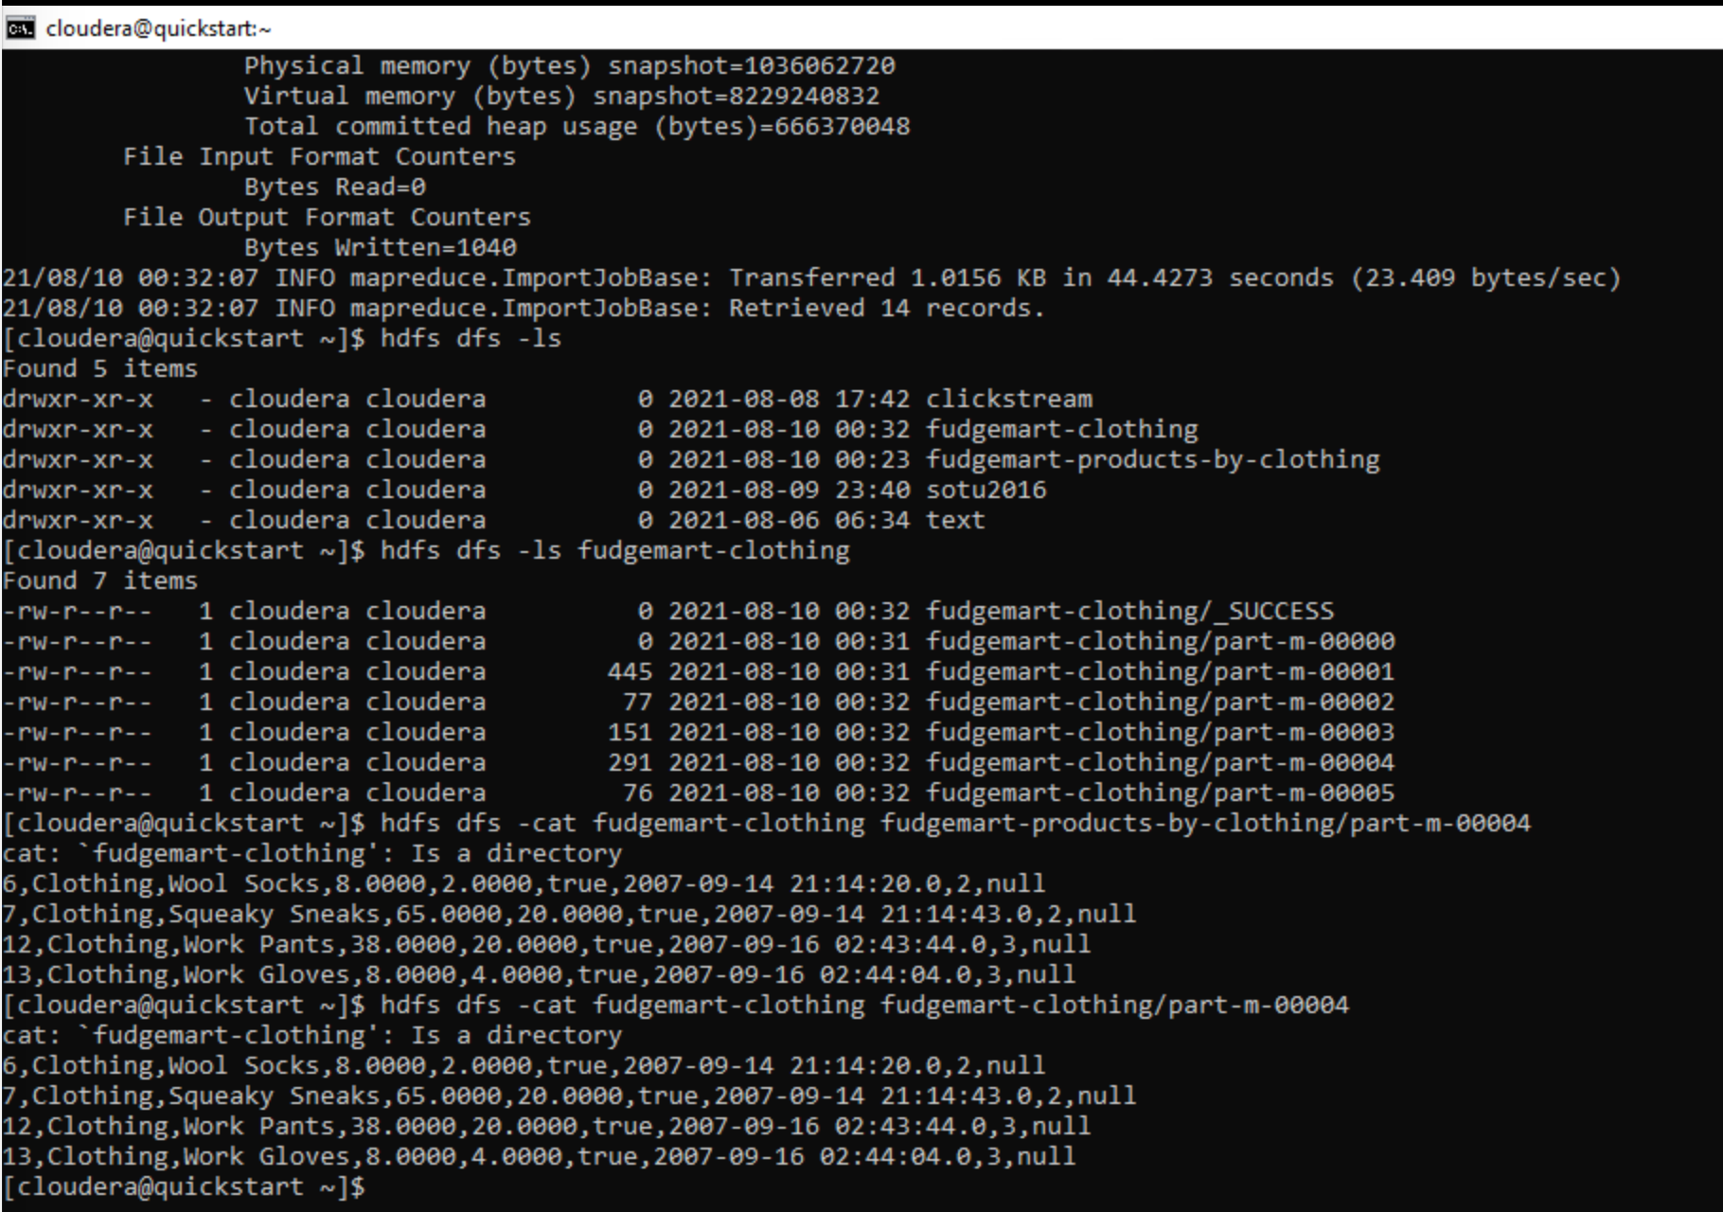

1. Let’s import HDFS data into MySQL. Record each command you type as your solution:
   1. Load datasets/tweets/tweets.psv into the HDFS folder tweets
   2. Login to MySQL: mysql -u root -p the password is cloudera. Create a database twitter
   3. Create a table called tweets inside the database twitter the table should have columns for id, timestamp, date time, username, and tweet_text.
   4. Export the data from HDFS into the MySQL table.  
      TIPS: If your SQOOP job fails it is likely due to the table constraints such as selecting a data type too small for the imported data. Try to insert a row in the table using a sample from the HDFS data. This will help you to ensure your chosen data types will work.

Solution:

--create tweets folder in HDFS

**hdfs dfs -mkdir tweets**

--create tweets data from datasets/tweets.psv file

**hdfs dfs -put datasets/tweets/tweets.psv tweets/**

--view the contents from tweets file

**hdfs dfs -cat tweets/tweets.psv**

--connect to mysql instance

**mysql -u root -p**

--create twitter database

**show databases;**

**create database twitter;**

**use twitter;**

--create tweets table

**create table tweets(id bigint, timestamp varchar(50), tweet_date varchar(50), username text, tweet_text text);**

**describe tweets;**

--export tweets data from HDFS into mysql tweets table using sqoop

**sqoop export --connect jdbc:mysql://cloudera/twitter --username=root --password=cloudera --table tweets --export-dir=tweets –input-fields-terminated-by=”|”**

--view the data from mysql table

**select * from tweets;**

Evidence:

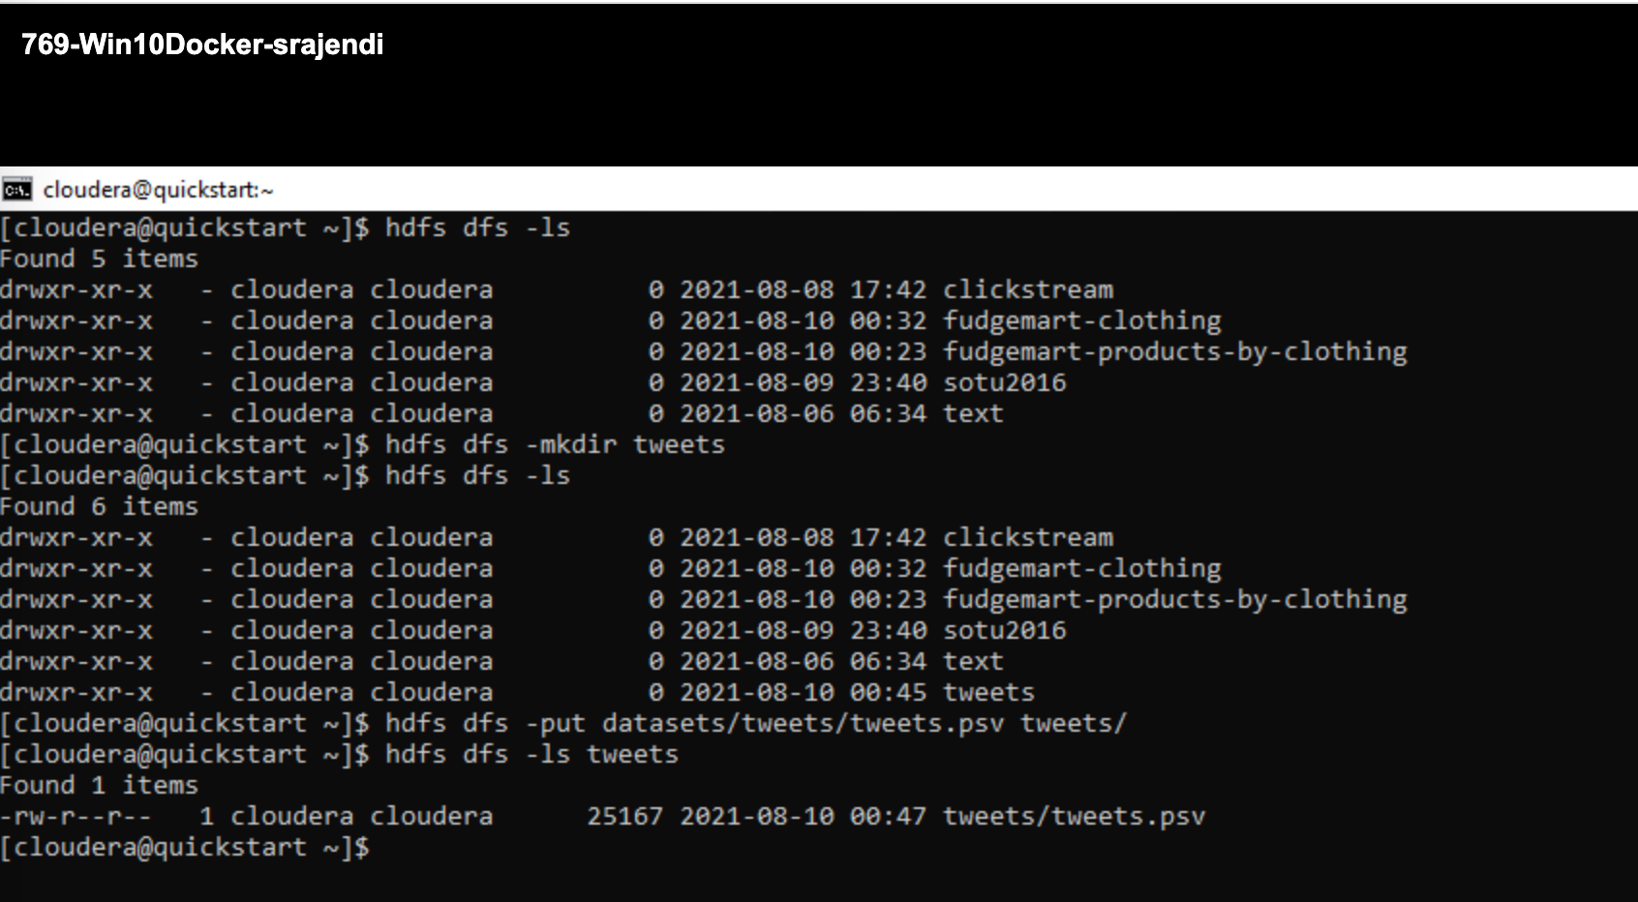

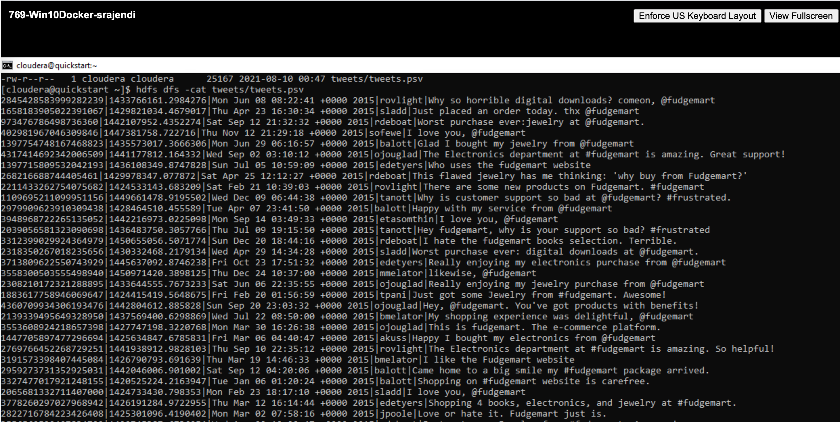

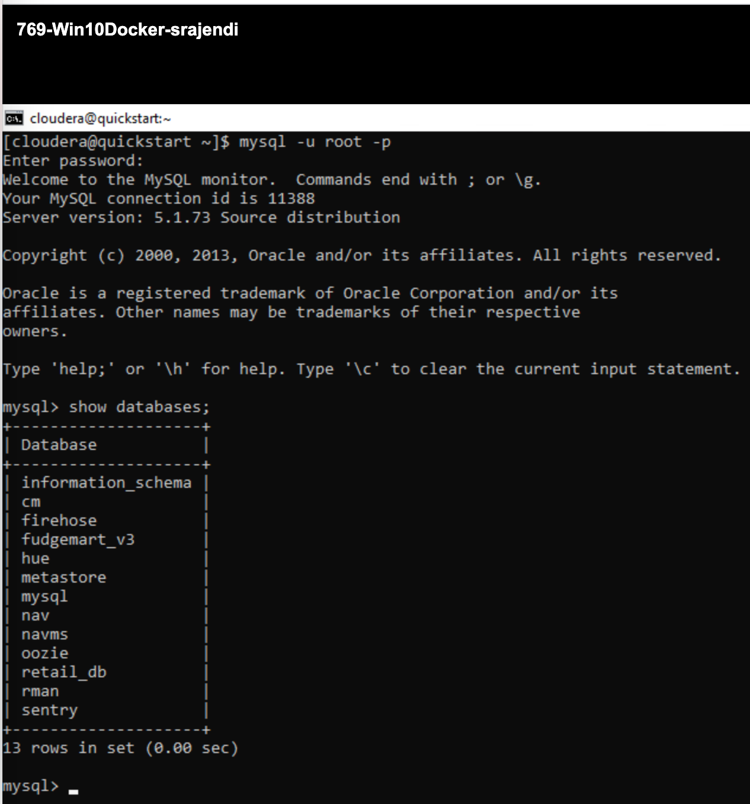

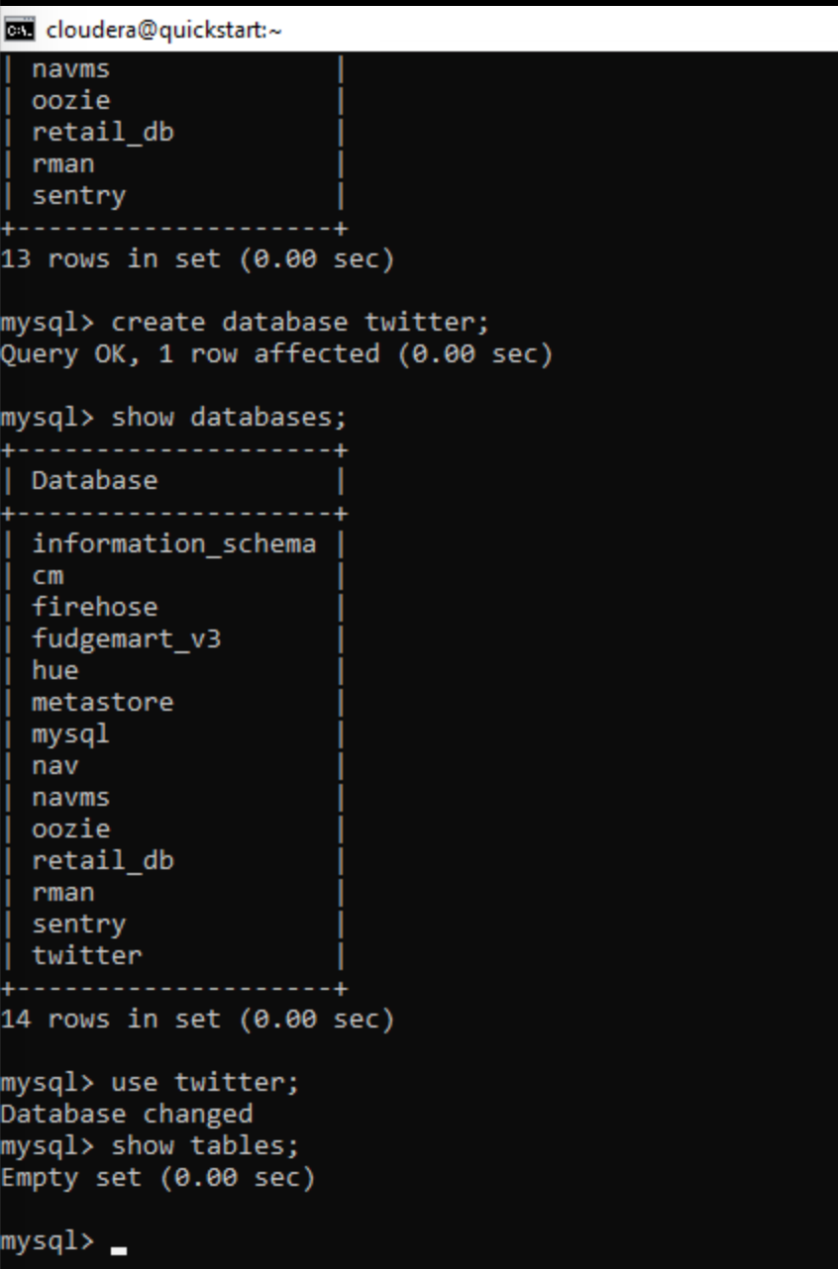

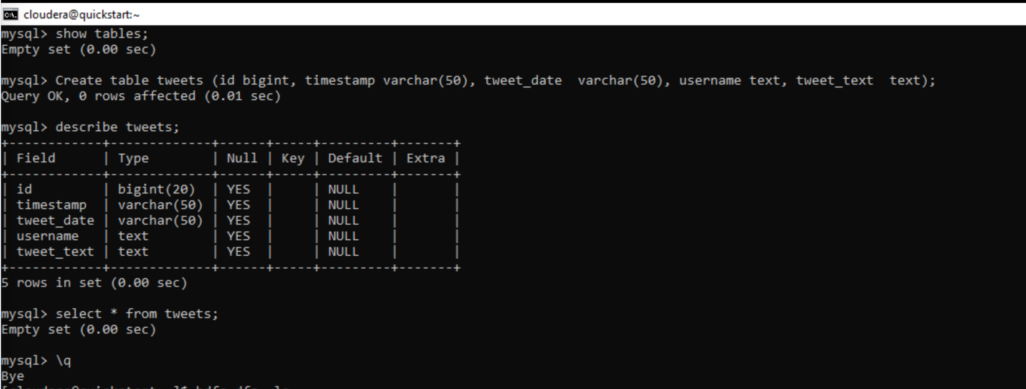

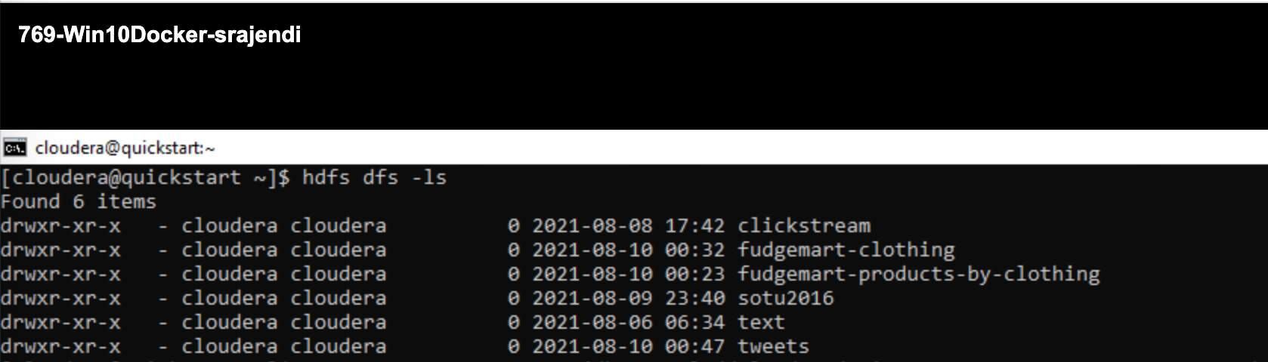

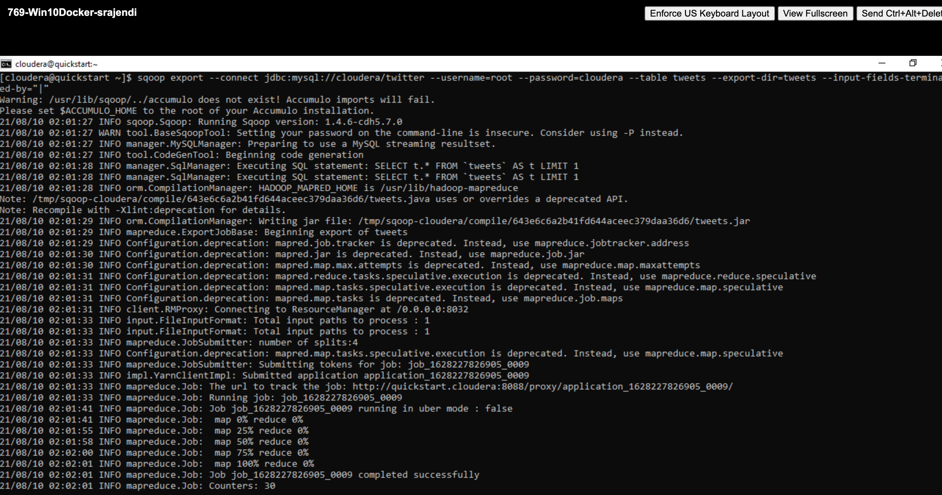

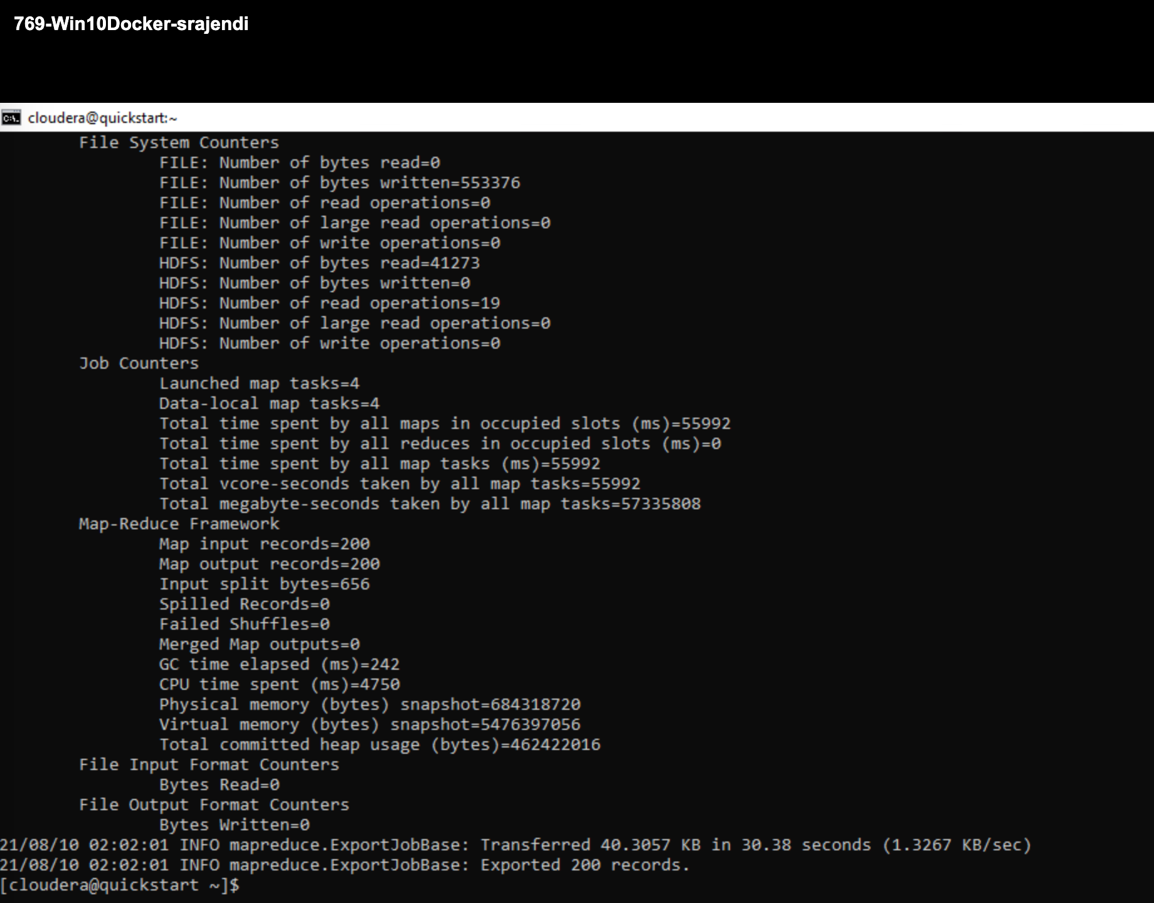

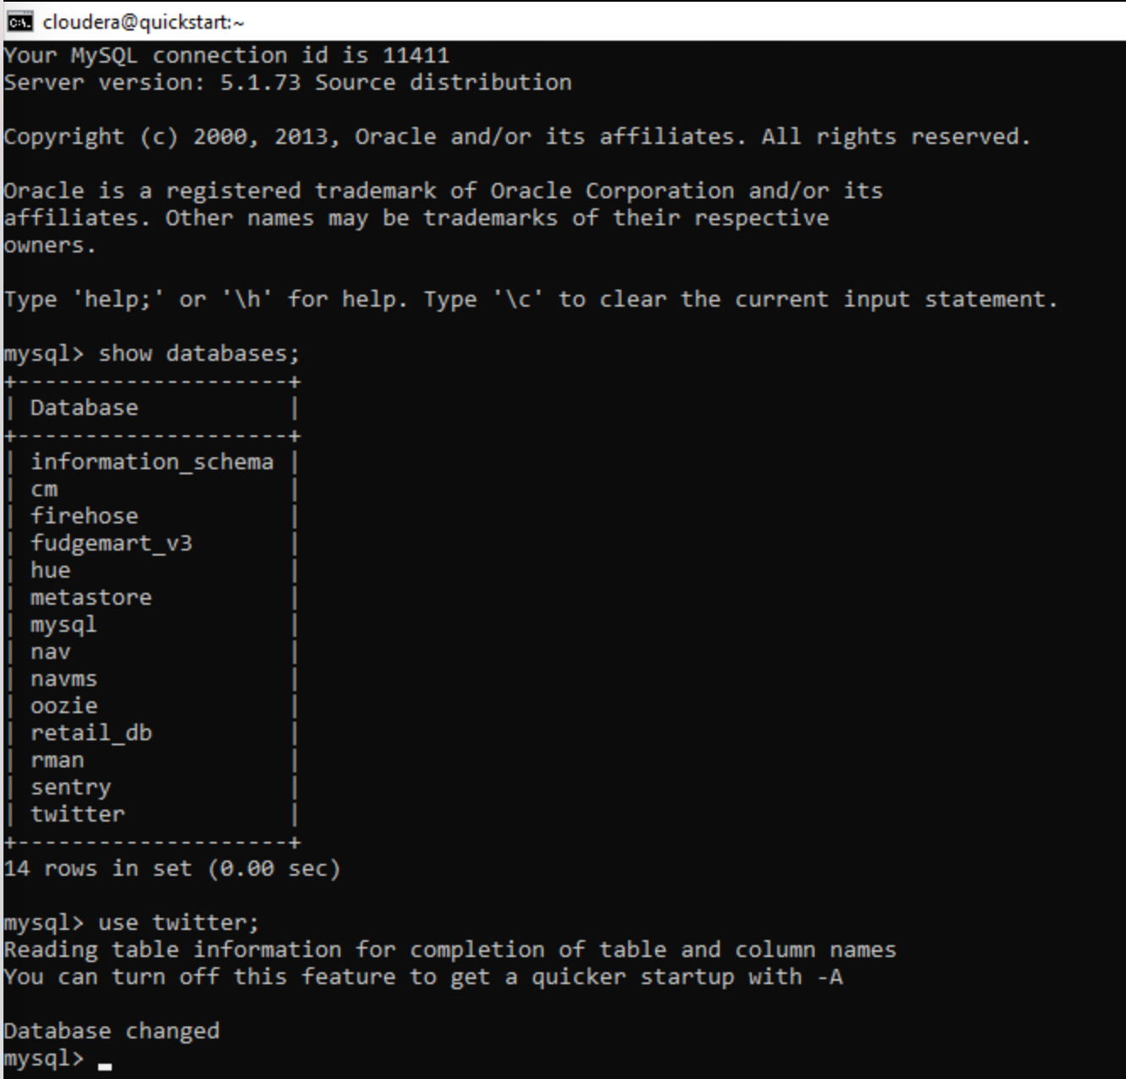

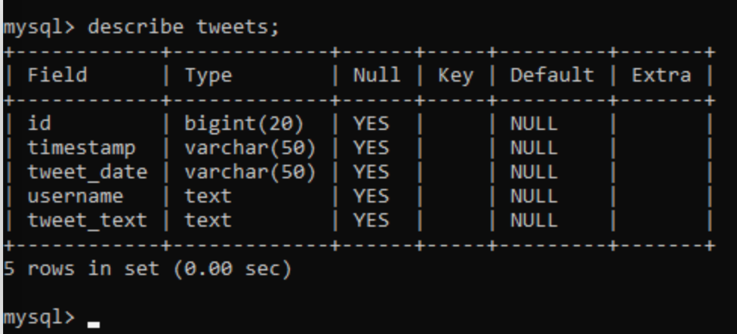

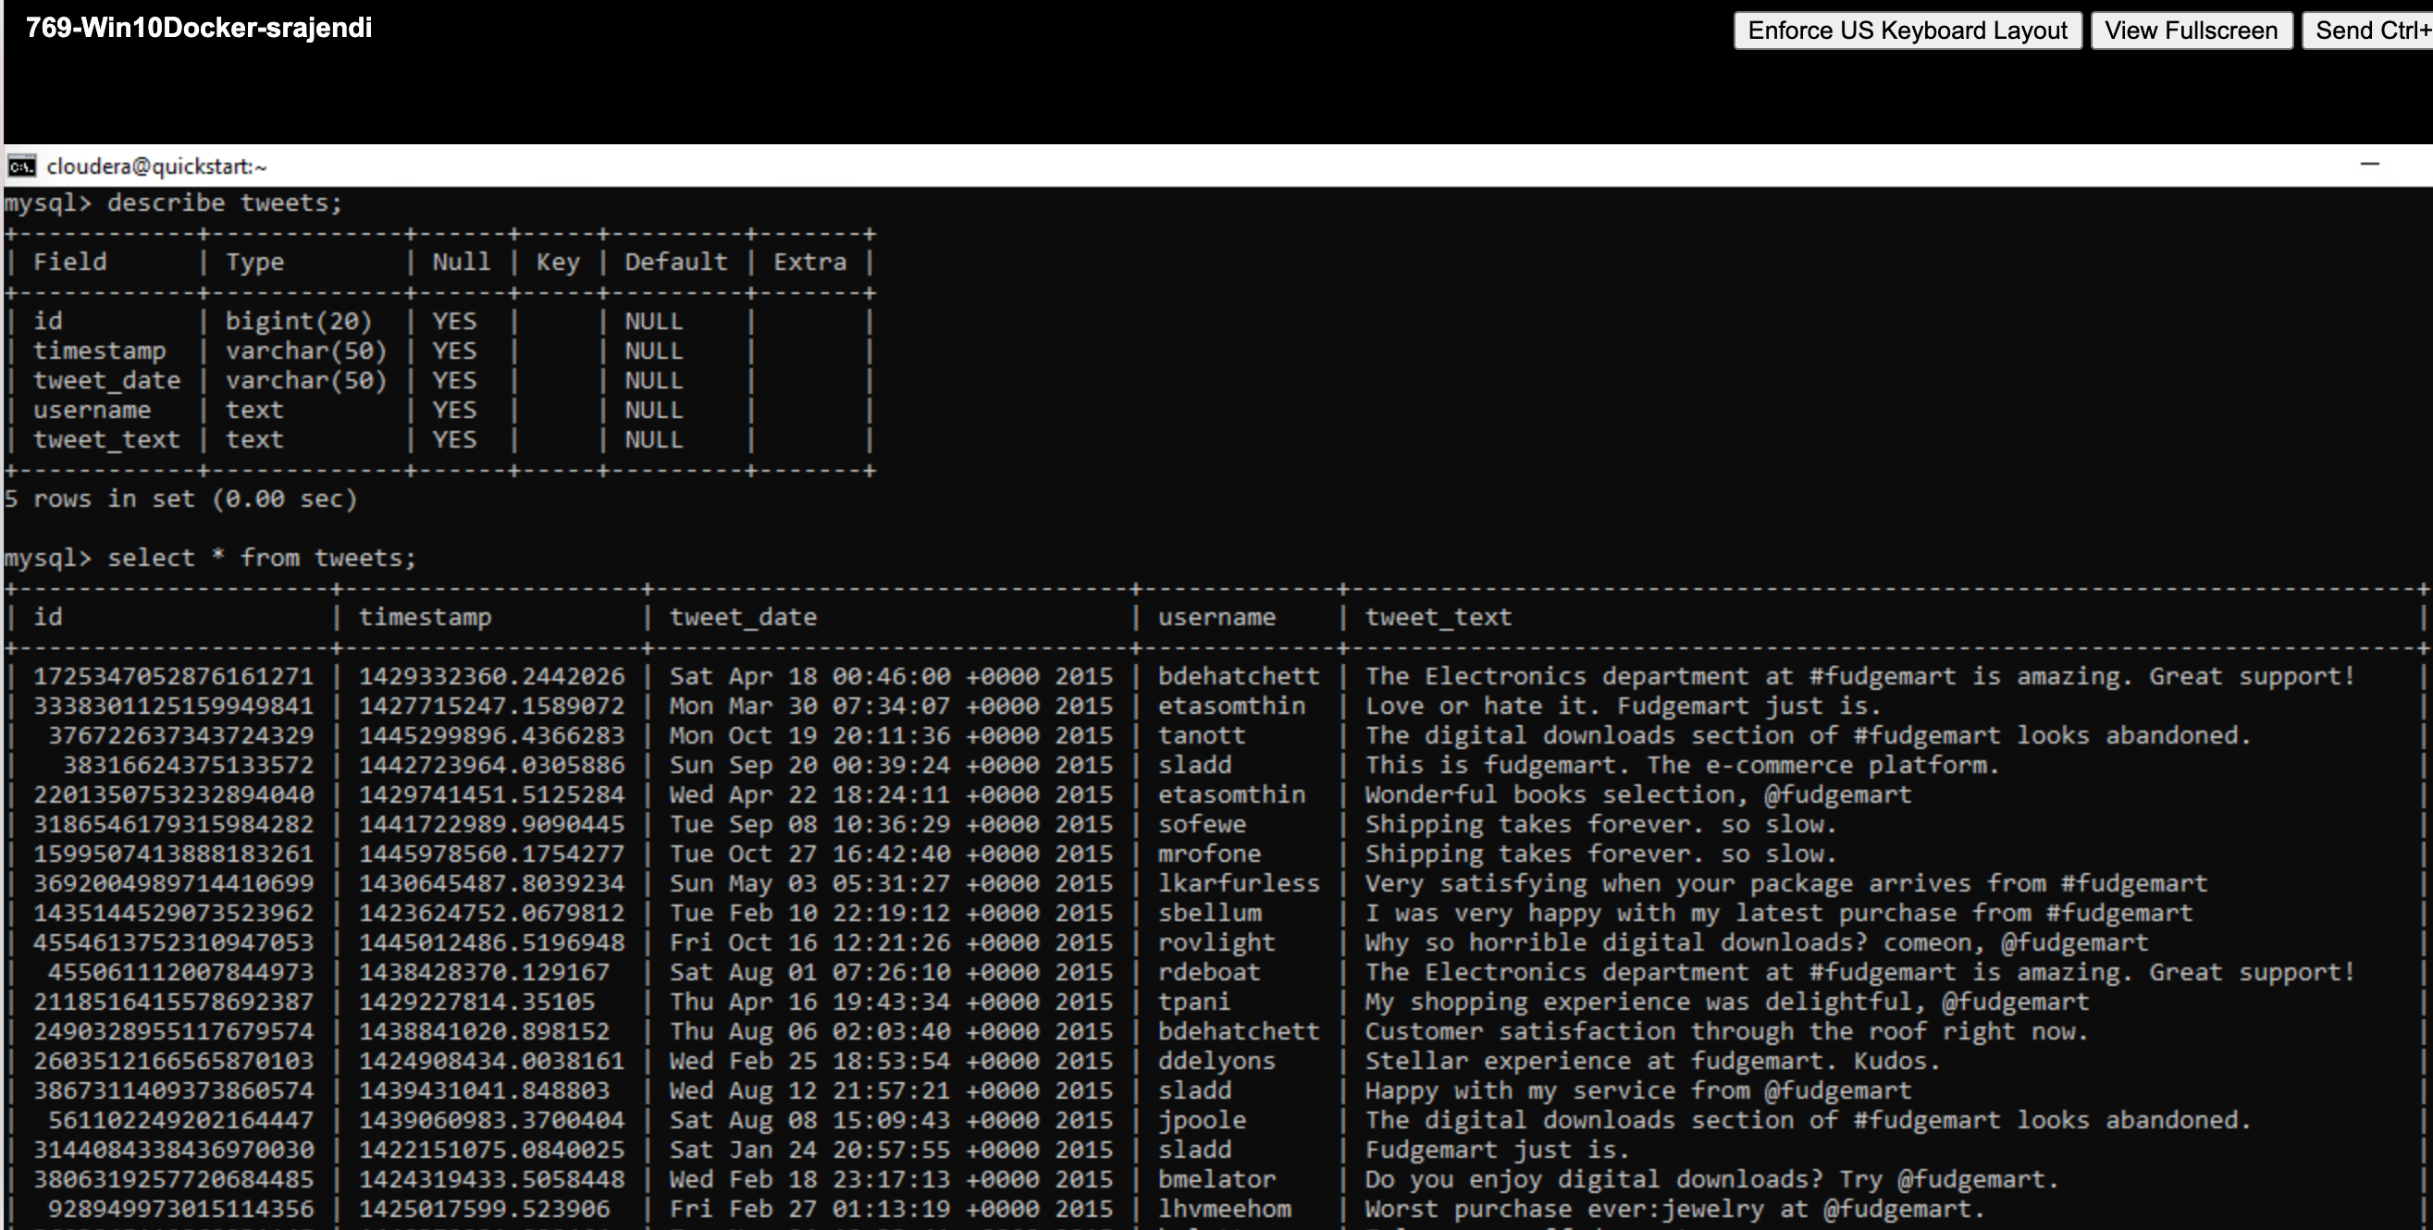

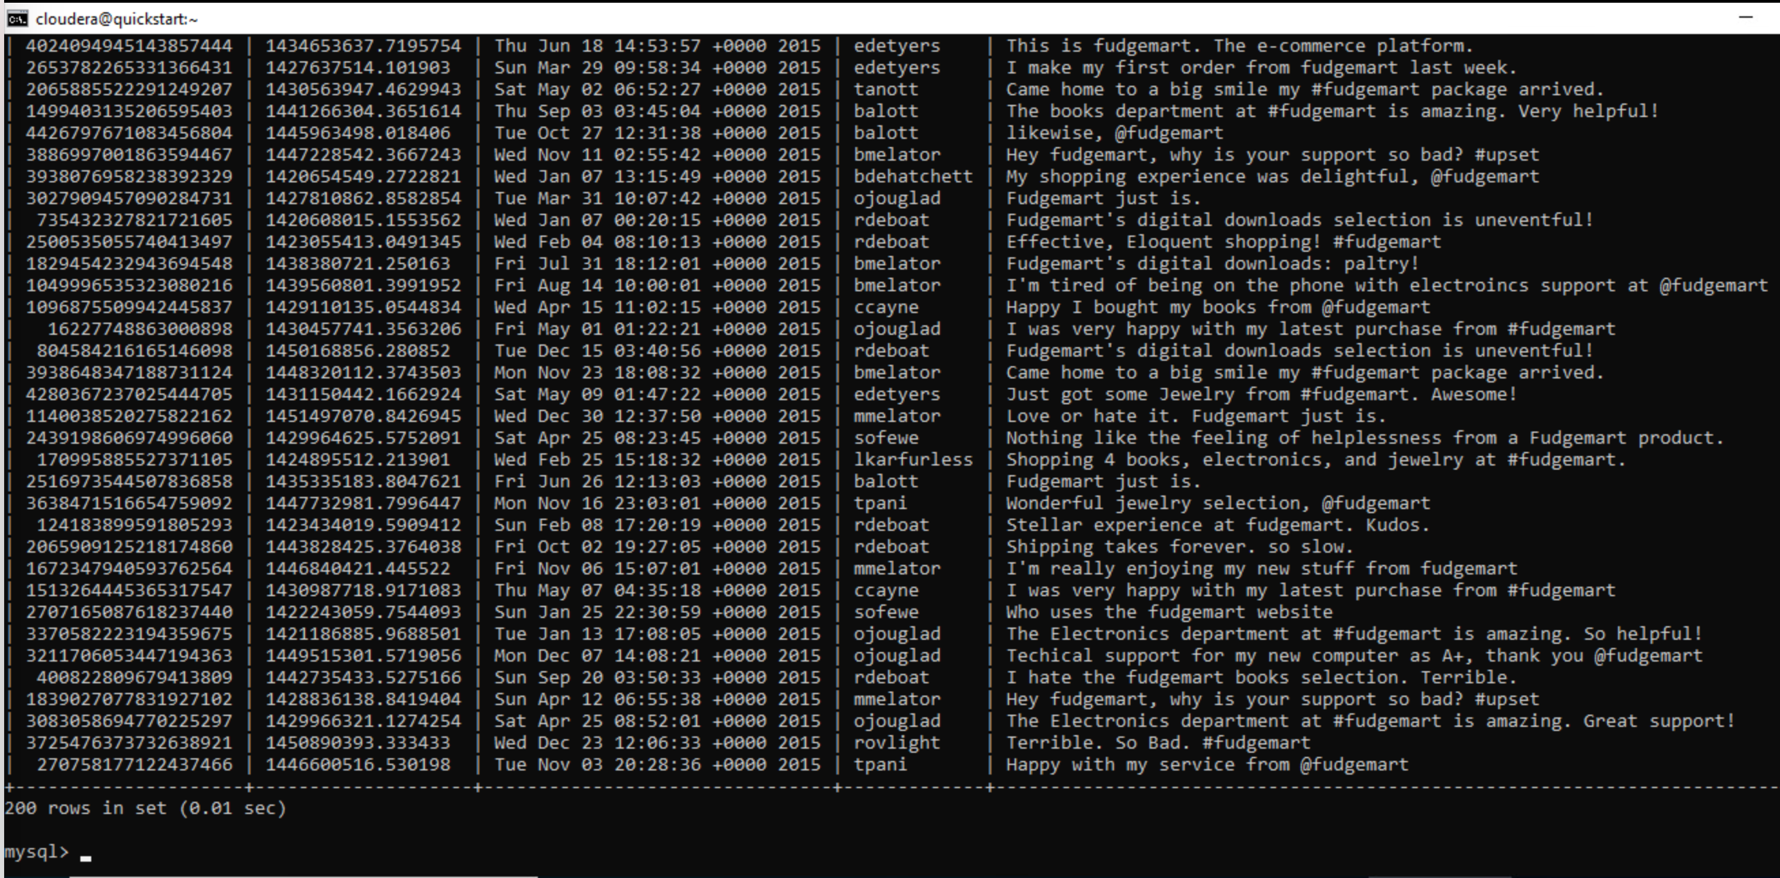

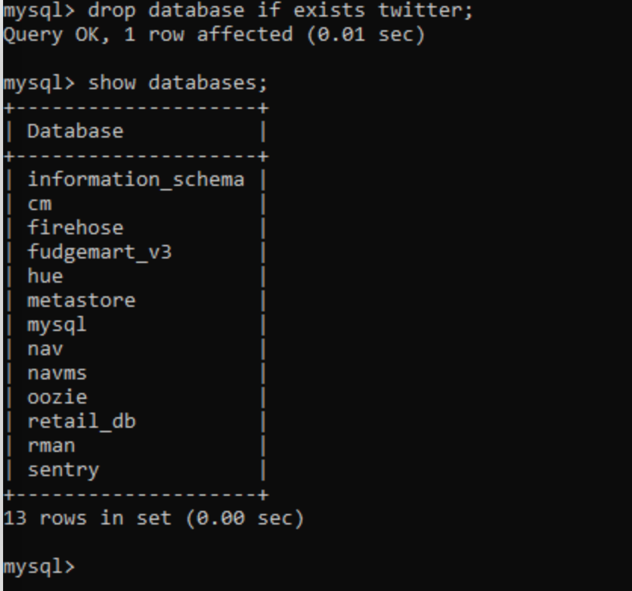

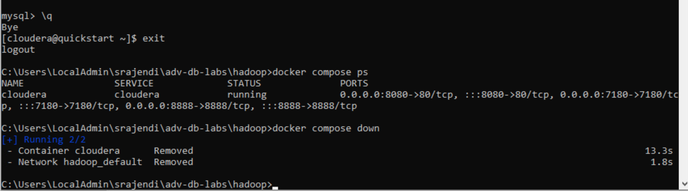

# **Appendix**

